
Blind Citizens Australia
Parent News (August 2014)

Welcome to the August 2014 edition of Parent News!

In this edition you will find the following items:
- Early intervention orientation and mobility research report
- Research study into the psychological health of adolescents who have a vision impairment
- Braille Tutor App for iPad
- Raising Children Network, an online resource for parents
- Early Childhood Intervention- the key players to your child’s development
- Vision Australia Further Education Bursary
- The Companion Card Scheme
- An Introduction to Acting course for people who are blind or vision impaired in New South Wales
- Barwon Head’s Victoria Holiday House for Rent
- BCA Conventions 2014

Early intervention orientation and mobility research report
Written by: Bronwen Scott, O&M Specialist, Independent Options for Mobility

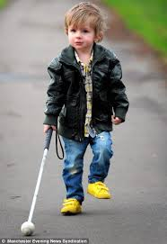
Orientation and mobility (O&M) is recognized as one of the core domains of the Expanded Core Curriculum (ECC) for children who are blind or have low vision. Despite this, O&M in the early childhood years is a relatively new area within the profession and O&M intervention, particularly early long cane mobility, is not routinely provided in Australia for this age group.

I am an Orientation and Mobility (O&M) Specialist from Independent Options for Mobility who is completing research into Early Intervention O&M. I am in the final stages of completing a doctoral research project into O&M within the early childhood context, based upon work I did in Western Australia in the mid-2000s as a member of the Department of Education Vision Education Service Early Childhood Team. Within this service O&M skills and techniques, including the long cane, were introduced to children as young as 14 months of age. The successes I observed prompted me to undertake the research.

As an O&M specialist, I am very aware that much of the current research within the field comes from the perspective of sighted O&M professionals. It was therefore important to me to present the perspectives and experiences of parents and children involved in the O&M process, as well as those of early childhood visiting teachers involved in the program. I collected data through interviews, along with archival documents and video material, to explore the experiences of early O&M and long cane mobility within this group.

The results of the study strongly support the early introduction of O&M intervention, including long cane mobility. The children in this study all successfully learnt long cane techniques at a very young age, which then positively impacted on their learning in other areas of the curriculum as they entered formal education settings.

As a part of this process, I found that children developed a sense of ‘ownership’ toward their own long cane mobility. This was developed in part by allowing children a choice in cane colours (or decorating white canes), and by using cane ‘names’, which helped personalize them and make them a ‘part of the family’. For parents, seeing their very young child moving confidently and independently through different environments gave them a sense of pride and excitement around their child’s potential, and all parents became strong advocates for early O&M intervention.

Importantly, the introduction of early long cane mobility enabled children to have a high degree of personal control over their own learning and movement. This supports the views of Joseph Cutter and Daniel Kish, O&M specialists from the United States, who advocate for the long cane to be introduced as early as possible. I also found that the introduction of early O&M intervention helped teachers facilitate the outcomes of the Australian Early Years Learning Framework, which are: children have a strong sense of identity, children are connected with and contribute to their world, children have a strong sense of wellbeing, children are confident and involved learners, and children are effective communicators.

One of the most significant findings was that early O&M intervention can potentially change perspectives toward blindness by teaching the skills of independent movement at a developmentally appropriate age. For the individuals in this study, the long cane was seen to be a natural extension of the young child’s body, a tool allowing them to develop their other perceptual senses to safely and effectively move through the world. In doing so, children also developed the body, spatial and environmental concepts that are essential for independent travel. The early development of O&M techniques assists others to understand that children with vision loss can be as independent as their sighted peers, they just learn and perceive their world in different ways.

For many years, it has been argued that young children are not ‘ready’ to learn long cane mobility until they have achieved particular developmental milestones. This means the long cane is often not introduced until children are entering preschool or primary school. However my study, and other work within the United States, is indicating children can learn long cane skills at a very young age, and that this has benefits across all areas of development and learning. I would encourage all parents of young children to access O&M services at as young an age as possible.

Some of my published work relating to this research can be linked to from the Independent Options for Mobility (IOM) website. IOM is a Melbourne-based partnership providing training and education for independent travel. Independent Options for Mobility is a registered service provider under the National Disability Insurance Scheme (NDIS).

For further information about IOM please visit the website: www.options4mobility.com.au or contact either myself or Dean Johnson at info@options4mobility.com.au
Research study into the psychological health of adolescents who have a vision impairment

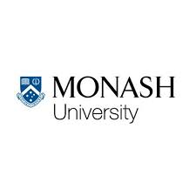
Ross Anderson, a PhD candidate in the School of Psychological Sciences at Monash University and supervised by Dr Narelle Warren and Dr Stuart Lee, is undertaking a study into exploring how vision impairment affects the psychological health of young people and what strategies or resources are useful in handling these effects.

Ross’s interests in this area are both personal and professional- his own legal blindness from Retinitis Pigmentosa has highlighted the importance of capturing the experiences and perspectives of people with vision
impairment to inform policies, services and resources.

Ross hopes that this project will not only provide insights useful in guiding the improvement of services available for adolescents with vision impairment but also empower these adolescents to engage collaboratively with service providers around their needs.
The study involves learning more about the following:
1) what makes up and should be looked at when assessing psychological wellbeing
2) how vision impairment gets in the way of their psychological wellbeing; and
3) how adolescents handle their vision impairment when it gets in the way.
Are you or do you know an adolescent with vision impairment?
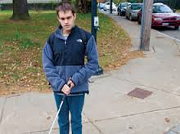
The following target adolescents who feel they have significant vision impairment are invited to participate in the study:
1) between 12 and 18 years old
2) do not have a cognitive impairment or any other impairment of their senses; and
3) who are comfortable conversing in English in a group setting.

What is involved?
This study has two phases.
In phase one, adolescents will:
1) attend a 1-hour training session on respectfully recording environmental sounds
2) record and reflect on sounds in their own time to respond to research questions and,
3) attend two 2-hour group sessions where their recordings will be played and discussed.
In phase two they will:
1) complete activities to identify common themes in the recordings and discussions and,
2) then come up with suggestions for service providers and other stakeholders.


Adolescents can choose to take part in phase one or both one and two, and will be given two $10 Coles-Myer gift cards per phase as reimbursement for their time.

If you are interested please contact Ross Anderson at ross.anderson@monash.edu or by phone between 9.30am-5pm on Monday-Friday on 0475508442.

If you are under 16 years of age please contact Ross with your parent or guardian.

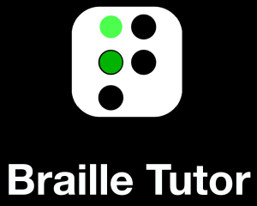
Braille Tutor App for iPad
Written by: Ray Cheung
A year ago, I was unsuccessful in my search for an accessible iPad app to help my son, Micah to learn Braille (especially those tricky contractions). I believe literacy (and therefore braille literacy for the blind and low vision) is key to success in the classroom and workplace. Statistics show that the majority of blind people who are braille literate are employed.
I developed the Braille Tutor app for iPad with the help of a number of visiting teachers and educators. Braille Tutor provides an interactive learning experience for a sighted or blind braille
learner. He hopes it can help other braille learners
pick up braille skills or consolidate their knowledge.

The App is made for the iPad and can be used with onscreen keys or home keys on a Bluetooth keyboard. It is self-voiced, but also works well with iOS accessibility, and a refreshable Braille display for reading Braille. Feedback on progress is immediate and useful hints are provided to aid learning. Braille Tutor is available now on the App Store for free download, which comes with the first 19 lessons. In-App purchase for the remaining 72 lessons for contracted Braille is available for the price of a song.

For more information, visit the website http://ienabletechnology.com/braille-tutor/ or email ray@ienabletechnology.com

Raising Children Network, an Online Resource for Parents


The Raising Children Network is an online Australian resource used to provide information to assist parents with the day-to-day decisions of raising children, and to also help parents and carers look after their own needs. This is also a website for the wide range of professionals and agencies who work with parents every day.
The website contains information about parenting from newborns to teens, and also about providing support to children with special needs. The website includes a variety of resources including: interest articles, newsletters, parenting podcasts, interactive guides, development guides, video resources and discussion forums. The “My Neighborhood” feature on the site also gives users the ability to connect with others in their area. Links to national and state resources, services and support organizations for parents and families can also be found on the website.
The website is supported by The Australian Government, Department of Social Services, Murdoch Children’s Research Institute, Parenting Research Centre and the Royal Children’s Hospital Melbourne.
Visit the website: http://raisingchildren.net.au/
Early Childhood Intervention - The Key Players to your Child’s Development
Source: Raising Children Network, http://raisingchildren.net.au/

It can sometimes be overwhelming for parents raising a child who is blind or vision impaired. A great way to help parents through the maze of all things blindness related, is to consider linking into early intervention services. These services can connect you to resources and support soon after your child’s diagnosis, to ensure that the development of your child’s abilities is maximised and that they can participate all aspects of life to the fullest.
Blindness and vision impairment can affect various areas of your child’s development. Some examples include: communicating (eg. lack of awareness of the need to turn their head to face the person speaking when in conversation), social interactions (eg. having trouble making friends), movement (eg. the child might avoid physical activities because they can’t see what is around them), learning to read and write, and playing (eg. being afraid to touch certain textures or explore areas).
Early intervention services provide specialised support to children and families in the early years (from birth to school entry). Early intervention involves coordinating the expertise of key individuals who specialise is various aspects of your child’s development. They include;


Orthoptists will assess your child’s level of vision (including depth perception and colour) and work out what they can see in everyday life. Orthoptists will also provide recommendations around lighting and vision aids to help your child function in the most optimal conditions at home or at school.
Occupational therapists will assess and build your child’s ability to develop functional skills required to complete everyday activities such as dressing and toileting. Occupational therapists can also support your child by suggesting play activities to help with fine motor skills, social interaction and learning.
Physiotherapists will build on the child’s motor skills such as balance, sitting, crawling and walking. This is important as some children who are blind or have low vision might avoid physical activities because they can’t see what is around them, leading to poor muscle tone and posture. Physiotherapists can also help your child get involved in games and sports with peers, and also to get some strength-building activities into daily life.
Speech therapy can help with speech, language, eating and drinking skills.
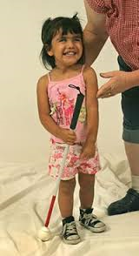
Orientation and mobility instructors will assist your child with building skills to get around safely inside the home and outside in the community (eg. crossing roads, walk on uneven surfaces, use steps, go on public transport). An orientation and mobility instructor will help your child learn how to use a mobility aid and guide if needed.
Other supports that your child can receive include special education, counselling, service planning and assistance with services such as kindergarten and child care.
To link into early education services, talk to your GP, local community health centres, hospitals and blindness agencies such as Vision Australia or Guide Dogs Australia.

Vision Australia Further Education Bursary
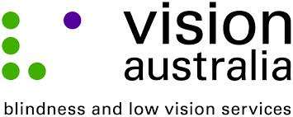
The Vision Australia Further Education Bursary is now open
for applications for 2015. These Bursaries provide assistive technology, laptops, magnification, audio or Braille devices tailored to the individual student’s needs.

To be eligible, applicants need to be an Australian citizen or permanent resident and be applying for, or enrolled in a tertiary course graded Certificate IV or above including undergraduate and post-graduate degrees.

The closing date for applicants is 31 October 2014.

For further information, contact Max Bini, Tertiary Education Consultant on 1300 84 74 66 or visit the Vision Australia website: www.visionaustralia.org/bursary
The Companion Card Scheme

Do you require a companion to attend movies, sporting events, concerts or other ticketed community events?
The Companion Card could be for you! The card is available to assist people who are legally blind to access ticketed events and have a ticket issued for their companion at no charge. . The Companion Card Scheme recognizes the need for some people to have an attendant or carer accompany them to community events,

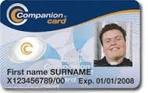
To obtain an application form, or for further information call 1800 893 044 or visit the website: http://www.companioncard.org.au

An Introduction to Acting course for people who are blind or vision impaired in New South Wales
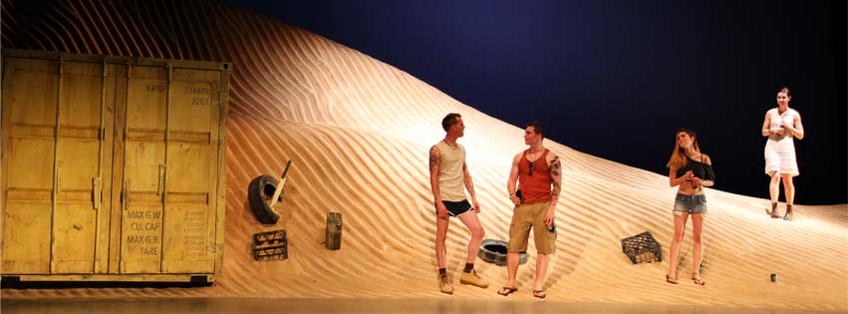
Vision Australia has partnered with the National Institute of Dramatic Art (NIDA) in NSW to offer a one day, introduction to acting course for people who are blind or have low vision. The course will aim to introduce the participants to the fundamentals of acting and basic stage directions so as to familiarise themselves with the physical space of a rehearsal room or theatre space.
Through practical activities, participants will discover the fundamental skills required for acting, identify how to create character and how to respond effectively to other performers. 16 people are required for the course. Payment direct to NIDA will confirm your place in the course.


DATE: Saturday 27 September 2014
COST: $95 per person. This is a discounted rate; usual cost is $135
For more information, call Kirsten Woodland on (02) 9334 3293 or Ben Moxey on (02) 4927 3322. Otherwise, visit the website: http://www.open.nida.edu.au/class/OCVA-14NFC1

Barwon Head’s Victoria Holiday House for Rent

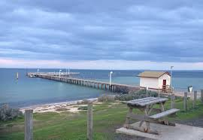
Vision Australia clients and staff who are blind or have low vision and their families and friends are invited to stay in our Barwon Heads holiday home (Lorna Lodge) on Victoria's Bellarine Peninsula. It is 23km from Geelong and about 1km from a shopping area. The house has recently been refurnished and refurbished. It is a small house with two bedrooms, but it is well equipped. It contains a king bed, bunks, and a single bed. A sofa bed in the lounge area means that it can sleep up to seven people. It is on a good-sized block with outdoor furniture, a barbecue, and play
equipment. The location offers beach and
lake swimming, hiking, golf, fishing, lawn
bowls, tennis and horse riding.

Rates:
- December to April inclusive, plus school holidays and public holidays: $40 a day plus a cleaning fee of $110 per stay.
- May to November inclusive, excluding school holidays and public holidays: $30 a day plus a cleaning fee of $110 per stay.

Conditions:
- At least one person in your party must be blind or have low vision and be eligible for Vision Australia’s services.
- Priority is given to people with blindness or low vision.
- Staff bookings are permitted with a maximum of 2 weeks in advance.
- Maximum booking time is seven nights per group or family per year.
- To ensure that the maximum number of people can book the house in school holiday periods - the maximum bookings at these peak times will be four nights. December and January are considered as one holiday period.

For further information, contact Vision Australia's National Call Centre on 1300 847 466

BCA Conventions 2014

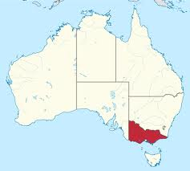
Victorian Convention (SA and Tassie residents welcome)
When: 4th October 2014
Where: Mercure Hotel Treasury Gardens, 13 Spring Street Melbourne
Time: 9am – 5pm
Theme: Putting Yourself Forward
Cost: Early bird (before Sept 12) $60, day rate $80, Dinner $55

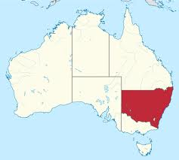
New South Wales / ACT convention
11th and 12th October 2014
Where: Travelodge, Newcastle NSW.
Time: Saturday 9am – 5pm, Sunday 9am – 3pm.
Theme: Achieving Your Goals and Aspirations
Cost: Saturday $65, Sunday $60, Convention dinner $55.

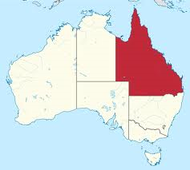
Queensland Convention
19th and 20th October 2014
Where: Vision Australia, 373 Old Cleveland Road, Coorparoo
Driving Day: Lakeside Raceway, Lakeside Road, Kurwongbah
Time: 9am – 4.40pm
Theme: Are you Engaged?
Cost: $30, dinner at own cost.

For more information on the BCA 2014 conventions, please go to the BCA website www.bca.org.au for a program overview or call the National Office to register on 03 9654 1400.


Do you have an idea for a story which could be published in the next edition of Parent News? We would love to hear from you! Anything from your own personal experience as a parent or teacher of children who are blind or vision impaired that you would like to share with other parents, any tips and hints, upcoming events or equipment solutions? Please send your ideas to hanna.mazzeo@bcaorg.au or call BCA’s National Office on (03) 9654 1400 or free call 1800 033 660.

Get the Word Out!
Do you know of a parent, visiting teacher, aide, government department or individual who should be receiving Parent News? Ask them to call us and we’ll make sure that they are on the receiving end of this publication! We are happy to provide Parent News in standard print, email, on audio CD, as a data CD or in Braille.

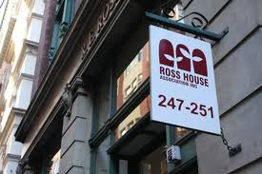

Contact us
Blind Citizens Australia
Ross House Level 3
247-251 Flinders Lane
Melbourne Vic 3000
Phone: (03) 9654 1400 or free call 1800 033 660
Fax: (03) 9650 3200
Email: bca@bca.org.au
Website: www.bca.org.au


https://www.facebook.com/BlindCitizensAustralia


@au_BCA

Disclaimer:
Blind Citizens Australia does not invite reliance upon, nor accept responsibility for the accuracy, completeness or up-to-date nature of the information contained in this newsletter. Readers should confirm information from another source if it is of sufficient importance for them to do so.

