
Blind Citizens Australia
Parent News (February 2015)

Welcome to the February 2015 edition of Parent News!

In this edition you will find the following items:
- Be My Eyes app
- The day your child realises that they have a problem with their sight
- Learn Ten Pin Bowling (Victoria)
- A smart soccer ball
- Research participants requested for Art project
- Support Group for Parents who are blind or vision impaired
- Advocacy Workshop for Families: Gold Coast QLD
- Snizzly Snouts: An inclusive book for children
- Airline Carrier Announces New Policy for Disabled Passengers
- Career Start Graduate Program
- Youth Disability Advocacy Service (YDAS) Steering Committee
- The Australian Inherited Retinal Disease Register and DNA Bank
- Individual Grants Program
- BCA membership, only $20 for lifetime membership!
- We want to hear from you!
- Follow BCA on Facebook and Twitter

“Be My Eyes” Could Revolutionise The Way People Who Are Blind Can Receive Sighted Assistance.
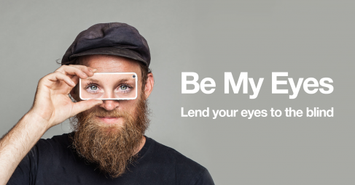

There’s a brand new app available for both IOS and Android that is set to make life a whole lot easier for people who are blind or vision impaired when they are alone and do not have a person physically present to assist them with the provision of visual information which is often critical to accomplishing a task. It’s called “Be My Eyes”.
How It Works.
Volunteers throughout the world can sign up to offer their assistance via video chat through their IOS or Android device. A person who is blind can download the app and register, so that whenever they need assistance with obtaining visual information, they can send a request and be linked with one of the volunteers via video. The camera on the device of the person requesting assistance relays the information required to the sighted volunteer, who then relays it back verbally. The types of assistance one can request are only limited to one’s imagination! We are already hearing stories of people who for example, needed to know when their milk or yoghurt was out of date. Somebody may wish to know the instructions for heating up a frozen meal, or the details on a container or box of medication. If it can be captured on camera, chances are that a volunteer will be able to interpret the information and relay it back. It sure beats waiting around until somebody is physically present to get the information, and has the potential to alleviate many moments of frustration in which one reflects that a bit of sight, even for thirty seconds, might just be enough time to capture the required information, rather than waiting for what might be an unspecified amount of time to find out something really simple, but which alludes a person who is blind or vision impaired.
“Be My Eyes” can be downloaded from the IOS and Android app stores. To offer your services as a sighted volunteer, go to http://www.bemyeyes.org. You might just make somebody’s day a whole lot less frustrating!
The day your child realises that they have a problem with their sight.
Written by Charlotte Mellor

Recently I met a Mummy of a VI Child in the local sensory center that I attend regularly with Scarlett. We chatted briefly and following our conversation she messaged me through my Through Scarlett’s Eyes Facebook page explaining that her son had only recently found out he was ‘different’ from other children, hence why she didn’t talk so much when we met. It really hit home that now whilst Scarlett lives in ‘ignorant bliss’ about her sight problem soon the day will come when there is some realisation about her condition. Since having the conversation with that Mum I have spent a lot of time researching this vital stage in a child’s life so when the time does inevitably come that I get it as right as I possibly can.
I stumbled across this article, Blindness – What it means in the mind of a blind child. The online article found at https://nfb.org/images/nfb/publications/fr/fr15/issue2/f150205.html is an edited and expanded version of a speech given at the Parents Seminar at the 1995 NFB convention. I think it is wonderful, insightful and perceptive piece, a must read for all parents. It has given me and awful lot to think about when handling ‘blind’ conversations with Scarlett.
To read the full story, please go to: www.throughscarlettseyes.com/blindness-what-it-means-in-the-mind-of-a-blind-child/

Learn Ten Pin Bowling (Victoria)

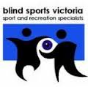



Blind Sports Victoria and the Victorian Ten Pin Bowling Association are partnering up to bring the Bowling 101 program to people who are blind or vison impaired, their family and friends.
What is Bowling 101?
The Bowling 101 Program is designed to introduce the sport to new participants as well as develop the fundamental skills of current bowlers.
Bowling 101 consists of eight sessions that steadily introduce new skills each week. The emphasis of the program is for participants to have fun, learn new skills and improve their bowling.
Who can participate?
The Blind Sports Victorian Ten Pin Bowling Association program is open people who are blind or vision impaired, their family and friends.
When: Every Thursday from 12th March 2015 for 8 weeks.
Time: 11am
Cost: $5 per session (Each participant will receive a welcome pack that includes a backpack, drink bottle and much more!)
Where: AMF Moorabbin, 938 Nepean Highway, Moorabbin, Vic, 3189
How to get there:: AMF Moorabbin is is a short 100 metre walk from Moorabbin Train Station and directly opposite the Moorabbin Police Station.
Registration and further information contact:

Blind Sports Victoria on 03 9822 8876 or;
Ten Pin Bowling Victoria on 03 9532 2219.
A smart soccer ball
Article from Vision Australia’s FYI newsletter
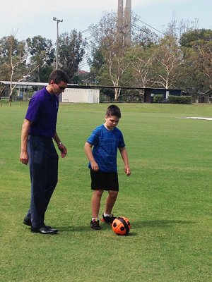
A new robotic soccer ball is set to improve social ball game participation for people who are blind or have low vision.
Members of Vision Australia’s Children’s Services team at Coorparoo Brisbane have been collaborating with research engineers at the University of Queensland in the quest for an electronic, sound emitting ball. The Interactive-Ball known as the I-Ball, makes a pre-selected noise when it is stationary as well as when it is moving, with the speed of the noise increasing as the ball picks up pace.
Although we are still at the very early stages, great progress has been made with development of the I-Ball. A development such as this makes one wonder with optimism about the future uses of technology.
For more information go to: http://robotics.itee.uq.edu.au/~iball/

Research participants requested for Art project


Are you interested in being involved in an Art project conceived by year 12 student Emma Sutherland and are between the ages of 18 and 25?

Emma aims to create a piece of Art that will appeal to blind, low vision and fully sighted people.

Emma hopes to create an artwork that incorporates sound, smell, textures and visual components also. She hopes to interview people who are vision impaired or blind about sensory preferences and how they experience Art.


If you are aged between 18–25 and would be available to chat to Emma by phone please email her at: emmas15@rosevillecollege.com.
Support Group for Parents who are blind or vision impaired
Vision Australia’s Quality Living telephone group is for parents who are blind or have low vision and would like to touch base with other parents. The group will run during the day while children are at school and will start in early February.
If you are interested in joining this 8 week group or any of our Quality Living Groups, please contact Ros Chenery on 1300 84 74 66 or email Ros.Chenery@visionaustralia.org
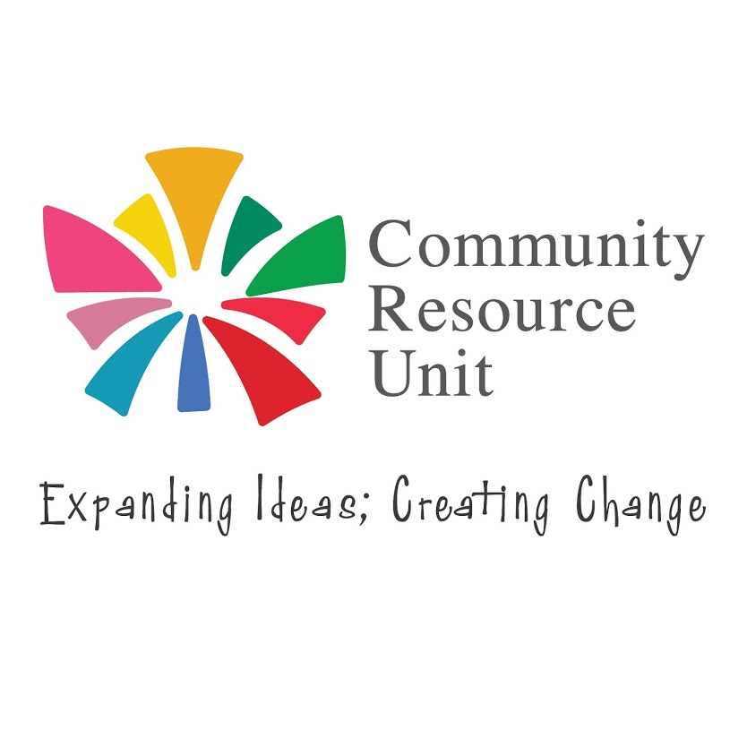
Advocacy Workshop for Families: Gold Coast QLD
Community Resource Unit (CRU) on the Gold Coast is pleased to announce a workshop for family members to be held at the Gold Coast on Friday 27th February. It is being held at the Robina Community Centre and is titled: The Meaning of Advocacy for Families: An Introduction to Principles and Strategies of Advocacy.
The presenters are Jeremy Ward and Lisa Bridle.
Jeremy will be well known to many for his work with Pave the Way, but also has a long history in both formal and informal advocacy, notably as Director of Queensland Advocacy Inc. for many years and as a family member. Lisa works at CRU as Senior Consultant with responsibility for leadership development and is the mother of a young adult son.
This workshop forms part of our family leadership initiative which invests in the capacity of families to be drivers of change for their family member with disability.
This workshop is open to all family members – not just those who have attended other CRU leadership events. We know that advocacy is a given when you want your family member with disability to have a full and included life, but there are not many forums where you can learn advocacy principles and strategies, reflect on your advocacy efforts and learn how you might be a more effective advocate. This workshop is designed to help families get a broader framework for their advocacy efforts, understand helpful principles, and learn some practical tips. The content will be relevant to lots of different situations, e.g. school meetings, dealing with professionals, interactions with service and health systems etc.
The intended audience for this workshop is family members – not paid workers— though families are welcome to invite supporters in their networks (e.g. neighbours, support circle members) to attend so those supporters have access to the same information, particularly if they are involved in meetings or other advocacy alongside the family.
This workshop is being presented in partnership with Gold Coast based group, Believe in People Inc. For more information about BIPI, please click link below.
http://believeinpeople.com.au
The cost of the workshop is $65, and applications close on Thursday 19th February 2015. You can register to attend the workshop through the CRU website: www.cru.org.au

SNIZZLY SNOUTS is an award winning inclusive book and audio CD by Jan Dewitte and Freya Vlerick. An octopus who writes, a knitting sheep and a tapir who thinks he’s an elephant …all of the Snizzly Snouts creatures are strange and quirky! They symbolize the wonderful diversity in our society. Let the Snizzly Snouts take you on a wonderful adventure! You can read with your ears, see with your fingers and feel with your eyes! The senses are engaged through Braille, audio, clear lettering, tactile pictures and vivid contrasting colours.
To purchase this book, go to www.ncbi.ie/shop/books/snizzly-snouts-(in002)
Airline Carrier Announces New Policy for Disabled Passengers

Australian airline, Virgin Australia, has made significant changes to its policies to make it easier for people with a disability to access lower airfares, in a move welcomed by the Public Interest Advocacy Centre.

As part of the change, people travelling with a carer can now make flight bookings by phone up to 331 days in advance at the internet discount rate, without the requirement to enter their carer’s name at the time of booking.

The move comes following the resolution of a complaint to the Anti-Discrimination Board of NSW.

The complaint was made after Jenny Brown found that she was unable to take advantage of discount airfares when booking flights for her disabled son because of Virgin Australia’s requirement to submit the name of her son’s companion carer at the time of booking.

“My son travels with a carer arranged by a nursing agency. We don’t usually know their name more than two weeks in advance when the agency finalises their roster, so we have had to book at the last minute,” Ms Brown said.

“Usually only expensive flights at the least popular, least convenient times are available.”

PIAC Senior Solicitor Camilla Pandolfini, who represented Ms Brown in the case, welcomed the changes.

“They make air travel more affordable and accessible for people with disabilities,” Ms Pandolfini said. “Travel is an essential service and this takes us one step closer to equality.”

A spokesperson from Virgin Australia said the airline was continually looking at ways to improve.

"We are committed to ensuring our guests with special access requirements have the best possible travel experience. The safety and comfort of our guests is our number one priority."

Career Start Graduate Program
Article from Vision Australia’s FYI newsletter
Beginning in March 2015, Vision Australia will pilot a 12 month Career Start Program to three eligible graduate. We are looking for people who are passionate about supporting people who are blind or have low vision through Vision Australia’s 2015 Career Start Graduate Program. There are two roles available, one for a graduate with a clinical qualification and another for a graduate with a business orientated qualification. To be eligible to apply for our 2015 Graduate Program, you must:
- either be blind or have low vision;
- be living in Australia and have permanent residence status;
- be willing and able to live independently in a location where the program is offered; and
- have completed a tertiary qualification within the past two years in an area where your capabilities and future employment prospects (within Vision Australia or elsewhere) will be enhanced by employment at Vision Australia for 12 months.
Applications close on February 11, 2015. To find out more please send an email to careerstart@visionaustralia.org or go to: http://www.visionaustralia.org/about-us/news-and-media/latest-news/news/2015/01/06/career-start-graduate-program
Youth Disability Advocacy Service (YDAS) Steering Committee
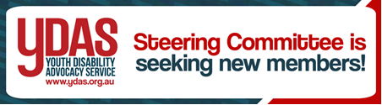

Steering Committee is seeking new members!
• Are you a young person with or without a disability (between 12-25) who is passionate about the issues and experiences of young people with disabilities?
• Do you want to get to know and work with other young people across Victoria with disabilities to act on the issues you care about?
• Want to gain some great skills and experience?
• Want to have the opportunity to represent YDAS and get involved on a range of projects?
…Then you definitely should consider joining the YDAS Steering Committee!
About the Committee
YDAS Steering Committee members are young people with and without disabilities who have a voice to Government about issues for young people, work on specific projects, have a say about what our service does and – have some fun at the same time!
About YDAS
YDAS works alongside young people with disabilities between the ages of 12 and 25 to raise awareness about their rights and to support them to achieve what they want. We provide one-on-one support through our individual advocacy service and also work on broader social issues affecting young people with disabilities through our systemic advocacy. This broader work is directed by the YDAS steering committee.
For more information including what is involved in the role and for an application form, please contact Madeleine at YDAS on 03 9267 3712 or email ydasprojects@yacvic.org.au. Applications will close on 16th February 2015 at 5pm. For more information about YDAS and what we do, please see our website www.ydas.org.au.

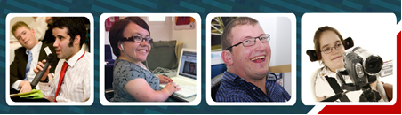


The Australian Inherited Retinal Disease Register and DNA Bank

Inherited retinal disease (IRD) is a leading cause of vision impairment in Australia.

The Australian Inherited Retinal Disease Register and DNA Bank was established as a national resource in 2009. It contains clinical and family history information for over 6,200 participants affected with an IRD or their family members. It also contains DNA collected from over 4,700 of those participants.

The results of genetic analysis of that DNA (which may include the specific genetic mutation causing a participant's IRD) are also recorded in this resource, as they become available. As the molecular mechanisms leading to inherited retinal disease become more clearly understood, novel therapies are being developed which will in time prevent or ameliorate loss of sight and improve visual function.

The early establishment of an affected person's genetic status is vital if he or she is to have the opportunity to take full advantage of these emerging therapies. The Australian Inherited Retinal Disease Register and DNA Bank is actively used by clinicians and researchers to identify participants who may be suitable for emerging gene-specific clinical trials, to improve their understanding and treatment of inherited retinal diseases, and to facilitate clinical counselling of patients.

With the support of its State bodies, Retina Australia is providing funds to expand the Inherited Retinal Disease Register and DNA Bank held in Western Australia at the Sir Charles Gairdner Hospital, to include all persons within Australia with an inherited retinal eye disease, and selected blood relatives who wish to participate.

The procedure is simple - a sample of blood or saliva is taken, and forwarded to the IRDR laboratory where the DNA is extracted and held in secure conditions. This material will form a databank of samples which will be made available to any gene therapy researcher in the world who seeks to make use of it.

In the future, when funds are available, the DNA material will be ‘sequenced’ to ascertain the individual’s specific errant retinal gene, or in the case of blood relatives, whether or not they carry the gene.

To participate or for more information contact:
AIRD Register and DNA Bank
Phone: 08 9346 2866
Email: scghmtp@health.wa.gov.au
Website: www.irdregister.org.au

Individual Grants Program

The Steve Waugh Foundation Individual Grants Program offers financial grants to children ages 0 – 25years affected by a rare disease and their families.

Grants must meet a criteria and be approved through a professional application process. Conditions to grants apply and may be for the purchase of equipment, medicine, treatment, therapies and other forms of assistance that improve the quality of life for the child and their family.

Applications for Individual grants are open 3 times a year and assessed by a panel of volunteer professional Paediatrician - our Medical Health Advisory Committee who forward recommendations to our Foundation Grants Committee. There is no limit on the grant amount that can be applied for.

The next grant round is open from March 1 – March 31.

Please refer to the website under Grants to download the Application Guide and Application Forms. www.stevewaughfoundation.com.au

If you need help to fill in the Application Forms;
• Read the instructions carefully.
• Contact your Medical Specialist, Paediatrician or Geneticist for help.
• Ask a Social Worker, friend or relative to help you.
• Make sure you have a copy of the most recent application form.

From time to time the Foundation may need to review this form so it is important you download the correct and most up to date application form from the website.

BCA membership, only $20 for lifetime membership!


Blind Citizens Australia is the united voice of blind and vision impaired Australians working to achieve equity and equality, positive community attitudes and accessible services that meet our needs.
Our Board, National Policy and Development Council, local branches and individual members identify and address issues through:

• Individual advocacy,
• Systemic advocacy,
• Peer support, and
• Provision of information.

Blind Citizens Australia provides:
• Information and Referral support
• Regular newsletters and audio magazines
• Website: www.bca.org.au , a facebook page, twitter account and email lists
• Newsletter for parents, ‘Parent News’.

Types of Membership
• Full Membership - legally blind Australian residents 18 years and over.
• Junior Membership – legally blind Australian residents under 18 years of age.
• Associate Membership - people who are not legally blind.
• Organisational Membership - for details contact BCA.

There is a membership form available on the BCA website, or you can Complete the attached membership form and return with a $20 lifetime membership fee to:

Blind Citizens Australia,
Level 3, 247-251 Flinders Lane
Melbourne Vic 3000

Or email to bca@bca.org.au

A Membership Registration Form can be obtained by calling the National Office on 03 9654 1400 or via the website www.bca.org.au

Do you have an idea for a story which could be published in the next edition of Parent News? We would love to hear from you! Anything from your own personal experience as a parent or teacher of children who are blind or vision impaired that you would like to share with other parents, any tips and hints, upcoming events or equipment solutions? Please send your ideas to bca@bca.org.au with the heading ‘parent news article’ or call BCA’s National Office on (03) 9654 1400 or free call 1800 033 660.

Get the Word Out!
Do you know of a parent, visiting teacher, aide, government department or individual who should be receiving Parent News? Ask them to call us and we’ll make sure that they are on the receiving end of this publication! We are happy to provide Parent News in standard print, email, on audio CD, as a data CD or in Braille.



Contact us
Blind Citizens Australia
Ross House Level 3
247-251 Flinders Lane
Melbourne Vic 3000
Phone: (03) 9654 1400 or free call 1800 033 660
Fax: (03) 9650 3200
Email: bca@bca.org.au
Website: www.bca.org.au


https://www.facebook.com/BlindCitizensAustralia


@au_BCA

Disclaimer:
Blind Citizens Australia does not invite reliance upon, nor accept responsibility for the accuracy, completeness or up-to-date nature of the information contained in this newsletter. Readers should confirm information from another source if it is of sufficient importance for them to do so.

