
Blind Citizens Australia
Parent News (November 2014)

Welcome to the November 2014 edition of Parent News!

In this edition you will find the following items:
- The Australian Inherited Retinal Disease Register and DNA Bank
- Teaching Voiceover to young children who are blind or vision impaired
- Evaluation of the Australian Government Department of Education Disability Support Program
- Adolescent Vision Impairment needs more focus!
- Ways to access the curriculum for students who are blind or have low vision
- Escorted Vision Impaired Tour To Queenstown, New Zealand
- Along Came Henry: A Guide Dog Story for Children
- I Spy with my Bionic Eye, a book written by Dr Dianne Ashworth
- Swimming for the Vision Impaired in Hampton, Victoria.
- Blind Skateboarder: Tommy Carroll
- Tricks to Learning Braille in your Teen Years or Later
- Fellowship of Australian Writers National Literary Awards
- Was your Centrelink pension card issued between the 1st August and the 3rd September 2014?
- BCA membership, only $20 for lifetime membership!
- We want to hear from you!
- BCA membership registration form

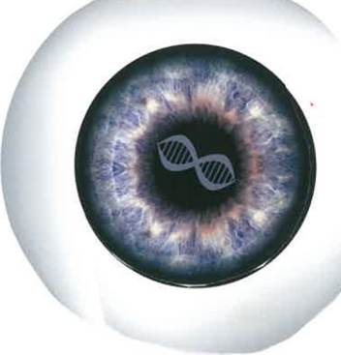
The Australian Inherited Retinal Disease Register and DNA Bank

Inherited retinal disease (IRD) is a leading cause of vision impairment in Australia.

The Australian Inherited Retinal Disease Register and DNA Bank was established as a national resource in 2009. It contains clinical and family history information for over 6,200 participants affected with an IRD or their family members. It also contains DNA collected from over 4,700 of those participants.

The results of genetic analysis of that DNA (which may include the specific genetic mutation causing a participant's IRD) are also recorded in this resource, as they become available. As the molecular mechanisms leading to inherited retinal disease become more clearly understood, novel therapies are being developed which will in time prevent or ameliorate loss of sight and improve visual function.

The early establishment of an affected person's genetic status is vital if he or she is to have the opportunity to take full advantage of these emerging therapies. The Australian Inherited Retinal Disease Register and DNA Bank is actively used by clinicians and researchers to identify participants who may be suitable for emerging gene-specific clinical trials, to improve their understanding and treatment of inherited retinal diseases, and to facilitate clinical counselling of patients.

With the support of its State bodies, Retina Australia is providing funds to expand the Inherited Retinal Disease Register and DNA Bank held in Western Australia at the Sir Charles Gairdner Hospital, to include all persons within Australia with an inherited retinal eye disease, and selected blood relatives who wish to participate.

The procedure is simple - a sample of blood or saliva is taken, and forwarded to the IRDR laboratory where the DNA is extracted and held in secure conditions. This material will form a databank of samples which will be made available to any gene therapy researcher in the world who seeks to make use of it.

In the future, when funds are available, the DNA material will be ‘sequenced’ to ascertain the individual’s specific errant retinal gene, or in the case of blood relatives, whether or not they carry the gene.

To participate or for more information contact:
AIRD Register and DNA Bank
Phone: 08 9346 2866
Email: scghmtp@health.wa.gov.au
Website: www.irdregister.org.au
Teaching Voiceover to young children who are blind or who have vision loss
Article courtesy of the Royal Institute of Deaf and Blind Children.

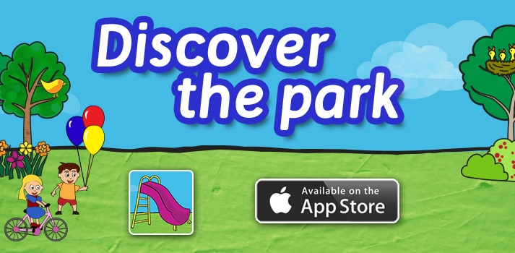
This fun app developed by the Royal Institute of Deaf and Blind Children, aims to introduce children with vision impairment to Apple’s popular VoiceOver software.

The ‘Discover the Park’ app was designed to introduce children who are blind, or who have vision loss, to Apple’s screen reader software, called VoiceOver.

The app aims to teach children the skills and confidence to navigate and control the app using VoiceOver technology. Learning to use assistive technology like VoiceOver is critical for children with vision impairment, and will help build a child’s knowledge, skills and confidence.

This app also encourages interaction and communication between children and their peers. ‘Discover The Park’ is set within a typical children’s playground. Children will use the VoiceOver screen reader to explore and navigate the playground. Interactive elements on the screen provide playful dialogue, engaging soundscapes and simple tasks to motivate children to explore and discover all elements on the screen.

In addition, the app features instructional videos explaining to children and their parents how to make the most of VoiceOver on the iPad. The app costs $4.99. For general enquiries or support contact the Royal Institute of Deaf and Blind Children on 02 9872 0369 or email apps@ridbc.org.au

Evaluation of the Australian Government Department of Education Disability Support Program
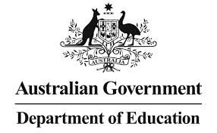
This survey is about your experience as a person with disability attending university. It is aimed at both students with disability currently attending university, as well as people with disability who have attended university in the past three years.

The survey asks questions about your experience as a student, and the support you may have received from your university to assist you in your education. In
particular, the survey seeks to understand:
- Any barriers you faced getting a university education.
- Whether you accessed support from your university to assist you in your studies.
- The types of support you received from your university and the impact these had on your education.
- Any suggestions you have for improving the support you received.

The survey will take 10-15 minutes to complete and can be found at this website: https://jfe.qualtrics.com/form/SV_3QMNuAaKksomg73

Ways to access the curriculum for students who are blind or have low vision
Written by Media Access Australia


Students who are blind or have low vision need technology, media and teacher instruction to be accessible so they can have access to teaching and learning.

Below is a list of the media types most common in schools and tips for providing more access for students who are blind or have low vision:

Textbooks

Textbooks, including books assigned in English, remain an essential resource. Because of their long history of being used in schools, alternative formats are well established. These include braille books, braille is a tactile language used by some people who are blind but not all children who are blind use braille, and large print versions using a larger font size for those who have low vision. These are made by specialist suppliers who receive permission from publishers to recreate the texts in a suitable format. These will have page numbers that correlate with the original version, allowing the student to follow along with the rest of the class. Braille and large print books tend to be large and cumbersome for students to carry.

Planning ahead

There can be long lead times in creating an accessible version of a textbook and teachers need to consider this when deciding on texts and plan well ahead of time.

A way to prevent delay is when deciding on texts, choose those that are already available as accessible eBooks or audio books.

Digital formats

eBooks

There are a number of emerging media, particularly eBooks and audio books, to improve access. While these formats are usually reserved for popular fiction, a growing number of specialist texts are becoming available.

An eBook is is available in electronic format and downloaded from the internet. These are commonly read on devices such as Amazon Kindles and iPads and apps for android and Windows tablets and smartphones.

Depending on the device, eBooks can allow the student to:

Magnify the text, Change colours and fonts or have the text read aloud using the device’s screen reader. While they will provide an accessible experience for the student, not all eReader devices or eBooks available are accessible for students who are blind. Currently Apple iBooks read on an iPhone, iPad or Mac desktop are considered the easiest to use for both students who are blind or have low vision. Amazon Kindles are also improving in their accessibility.

There are currently fewer eBooks available in Australia than in Europe and North America.

Audio books

Popular fiction and non-fiction books are becoming increasingly available in audio format. Vision Australia supplies audio versions of other texts, such as newspapers, cookbooks and manuals, to schools in Queensland, New South Wales, Victoria, the Australian Capital Territory, Tasmania and the Northern Territory.

DAISY (link is external) is a format of audio book specifically for people with disabilities. These are designed to provide a reading experience equivalent to that of a printed book and allows the reader to easily navigate between chapters. The Vision Australia Library (link is external) has over 30,000 titles in DAISY format.

PDFs

A growing number of classroom resources are available as PDF documents. The difficulty with PDFs is that some are accessible to people using a screen reader, while others are not. The accessibility will depend largely on whether the PDF has been created from a Word document (accessible), or whether it is a scan of another document which turns it into an image (inaccessible).

Ideally, all documents should be provided in PDFs created from Word documents or in Word document formats.

Videos and movies
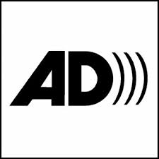
Audio description (AD) is a second audio track which communicates the visual elements of a video or performance providing access to video content for people who are blind or have low vision.

AD is available on approximately 35% of mainstream DVDs sold in Australia; however there is currently not a lot of educational content available. If a DVD has audio description this will be identified on the case. To turn the AD track on, go into the main menu of a DVD.

English prescribed texts videos with audio description

Years 7-10:
Dead Poets Society (2002 re-release only)

Year 12:
The Castle (2011 re-release only)
Elizabeth

There are also a number of suitable texts with audio description videos available such as Tomorrow When the War Began and The Hunger Games, listed in our audio described DVD database.

Online video

At this stage, limited audio description is available on online videos but this will change as it is more widely adopted across media, including television.

Websites

Websites can be the most accessible medium for a student using assistive technology. A student using a screen reader will be able to read the text on a webpage that is designed to be accessible. Information in images such as diagrams may be unreadable and some websites may be difficult or impossible to navigate using a screen reader as they have not been designed to meet accessibility guidelines.

When using a website as a resource in class look for an 'accessibility' statement (usually linked to in the footer) which tells you how accessible the website is. Ideally, the site should comply with international guidelines. Unfortunately not all websites are accessible.

Adolescent Vision Impairment needs focus!

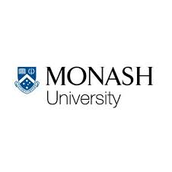
You may have heard about the project being run by Ross Anderson from Monash University to learn more about how the psychological wellbeing of adolescents (aged 12-18 years of age) is affected by vision impairment to help service providers improve their services.

He is now also looking to work with older adolescents moving into their young adulthood (19-25 years of age) to learn more about how vision impairment affects their psychological wellbeing: how they feel, think and spend their time. He wants to know:

- What makes up and should be looked at when assessing their psychological wellbeing;
- How their vision impairment gets in the way of their psychological wellbeing; and,
- How they handle their vision impairment when it gets in the way.

Can you or the young person you know be involved?
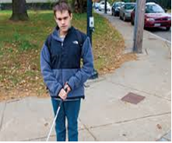
We are looking for young people who feel they have significant vision impairment:
- Who are between 12 and 25 years old;
- Who do not have a cognitive impairment or any other impairment of their senses; and,
- Who are comfortable conversing in English in a group setting.

What is involved?
This study has two phases. In phase one, those taking part will:
- Attend a 1-hour training session on respectfully recording environmental sounds;
- Record and reflect on sounds in their own time to respond to research questions; and,

- Attend two 2-hour group sessions where their recordings will be played and discussed.
In phase two they will:
- Complete activities to identify common themes in the recordings and discussions; and,
- Then come up with suggestions for service providers and other stakeholders.
Young people can choose to take part in phase one or both one and two, and will be given two $10 Coles-Myer gift cards per phase as reimbursement for their time.

If you are interested please contact Ross Anderson by phone between 9.30am-5pm on Monday-Friday on 0475508442 or at ross.anderson@monash.edu to arrange a time that suits you. If you are under 16 years of age please contact Ross with your parent or guardian.

Escorted Vision Impaired Tour To Queenstown,
New Zealand

6 Nights/7 Days
Depart Perth Sunday 24th May 2015 and returning Saturday, 30th May 2015

“Travel Tree has been successfully designing and escorting vision impaired tours for a number of years, specifically for Australian vision impaired persons.

Traditionally the tours have been to South East Asian destinations, but this year Queenstown New Zealand has been selected to ensure participants from all around Australia have easy access to the tour. There are many activities included in the itinerary to make sure there is plenty to do, but also to allow some downtime for shopping, resting and the opportunity for some optional activities.

Start planning, look for your sighted companions, and I invite you to join me on this wonderful journey.” George Booth: Tour Escort.

Package Pricing:
Per Person Share Twin $2,875
Single Room (sole occupancy) $3,380
Trip Includes:
• Economy class airfare Perth to Queenstown and return flying QANTAS.
• Current airline taxes and charges
• 6 nights’ accommodation Novotel Queenstown
• Full buffet breakfast daily,
• Roundtrip airport transfers Queenstown
• Activities: Twin challenge Shotover and rafting on the great Kawarau River/Lunch and wine tasting at Gibbston Valley Winery/Spectacular cruise on the Sprit of Queenstown across Lake Wakatipu to MT. Nicholas Station/4WD drive tour Discovery tour and lunch at Arrowtown./Queenstown to Cromwell with lunch in Clyde at the Post Office Restaurant./ Skyline Gondola & Restaurant dinner .
• Services of escort in New Zealand (subject to 20 persons participating on the tour from Australia).
Not Included:
• Meals other than stated above
• Telephone calls and alcohol
• Travel Insurance (All participants must have travel insurance)
• Passport cost
Note:
• Passports must have 6 months’ validity from arrival back into Australia
• All vision impaired persons must have a sighted companion. (If required, people can register and Travel Tree will endeavor to arrange a sighted companion to share).
Payments
A deposit of $350.00 per person is required within 7 days of confirmation of tour and the
balance around 6 weeks prior to departure. Full terms and conditions will be advised at time of enquiry.

For bookings and information contact Maxiema Lager on (08) 9382 5044 or maxiema@traveltree.com.au

Along Came Henry: A Guide Dog Story for Children

Extracts of this story thanks to Guide Dogs Australia.
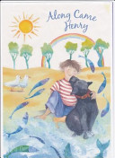
‘Along Came Henry’ is a beautifully illustrated and charming story of the transformation for BCA member Bev Larsson, after she met her guide dog Henry.

Bev wrote the book because she says that “people don’t always understand that her guide dog is different from a pet”. When Henry has his harness on he is working. He has had stringent training to become a guardian for Bev and when he is on the job, that is what he is focusing on. But Bev says some humans can’t resist.

‘Henry is such a good looking animal, he is gorgeous. I often hear “Oh aren’t you gorgeous”, and I say “Thank you, what about the dog?” laughs Bev.

Bev says that apart from being so handsome he has qualities that make him loveable on many levels.

‘He has got a beautiful personality’, says Bev. ‘He has a lovely temperament, he’s thoughtful, kind, considerate and he’s bright. He really looks after me.

Bev has a background managing child and family health services so she is knowledgeable about children in the age group the book is aimed at.

The book makes a wonderful addition to any children’s book collection, school or library.

For further information on how to purchase the book, go to http://guidedogs.com.au/home

I Spy with my Bionic Eye, a book written by Dr Dianne Ashworth

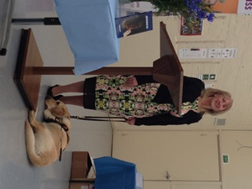
I am very pleased and proud to present my book, I Spy with my Bionic Eye. My story begins on 22nd May 2012 when I was waiting for surgery as first research participant in the Australian prototype bionic eye trials. Being first meant no one really knew what to expect. Of course with all the pre-clinical work that had been done before my surgery, everyone hoped all would go to plan. And it did!

This book is an adaptation of my journal, as I share eighteen months of my participation in the research. It includes switch on, a term used to describe the first time the device is switched on, drawings of what I saw when the device is activated and how testing in our weekly psychophysics sessions unfolded, as well as using the camera to see and moving about using a semi-portable unit.

As such, this book provides insight into the brilliance of Aussie science! But it is oh so much more. In it, I open my life up to share with the reader, too. Being diagnosed with retinitis pigmentosa in my mid-twenties was certainly one defining moment, one that changed its course. After my husband deserted me, I raised my two sons as a single mum, studied, volunteered and worked. During the middle of my participation in the bionic eye trials, I even completed a PhD. If you are interested in obtaining a copy, so far I Spy with my Bionic Eye is available online from Dorrance (the publisher), Amazon, Google Books, Angus and Robertson, Booktopia and more in paperback and as an e-book. If you do get to read it, I hope you enjoy. Dr Dianne Ashworth.

Swimming for the vision impaired in Hampton, Victoria.
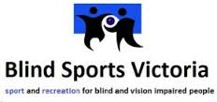
Blind Sports Victoria in conjunction with Sports Education Development Association will conduct a learn to swim program at the Re-Creation Swimming Pool in Hampton, Victoria.

A session will be conducted at 2.00pm on Thursday 20th
November and costs $5.

For further information or to register contact Blind Sports Victoria at info@blindsports.org.au or telephone 9822 8876 or BSV Swimming Co-ordinator John Groom on 9557 1716, 0400 993 059 or e-mail jrgroom@westnet.com.au

Blind Skateboarder: Tommy Carroll
Article by Justin Tejada
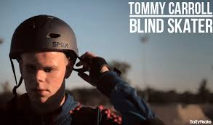
You need a few basic things to become a skateboarder. For starters, there’s the skateboard (duh). A strong sense of balance is key, and a general dislike of Rollerbladers can’t hurt (just kidding). Tommy Carroll, however, is proof that having eyesight is not a requirement. The 15-year-old is a ripping skater who has been blind since age two.

When he was 13 months old, Tommy was diagnosed with cancer of the retina. After months of treatment failed to produce positive results, doctors had to perform surgery to remove the cancer, which left Tommy blind. But being unable to see didn’t stop Tommy from leading a full life and enjoying himself. He first bought a skateboard on a whim when he was eight years old, but didn’t begin riding it regularly until two years later. “I picked it up because it was something that I could do individually and be creative with,” says Tommy, who lives in Glenview, Illinois. “When I started, I could barely do anything. I just had fun messing around.”

Tommy loved the feeling of freedom he had on his board and would spend hours practicing by himself and with friends. By the time he was in sixth grade, he was skating every day and learning new tricks, like different grinds and early-grab airs. Now Tommy has progressed to the point that his skills are earning serious attention. He is sponsored by Agent Skateboards and has been featured in The Skateboard Mag. Tommy is also looking for local competitions to enter.

Tommy loves riding in skateparks. Before trying a new run, he walks around the course to find the obstacles. He uses echolocation to tell where ramps and other skaters are. Here’s how it works: When Tommy skates, his wheels make a sound. That sound bounces off objects in the skatepark, letting him know what’s around him.

Aside from minor injuries like a chipped tooth and sprained ankle, Tommy has not been seriously hurt. “I will go for stuff and slam hard a lot of times, but I have really not hurt myself badly,” he says. “I don’t want to jinx myself though.”

In March, Tommy was able to ride with legendary skater Tony Hawk, who had seen a YouTube video of Tommy and wanted to meet him. “He’s way better than I thought,” says Hawk. “His blindness doesn’t hold him back.” That’s because Tommy won’t let it. “I don’t like to put any limits on. I just try anything,” he says. “It might help that I can’t see because I just see [tricks] in my mind and think I might as well try them.”

That gung-ho attitude blew Hawk away. “There are a few tricks he does that are frightening to the sighted skater because your back is turned to the ramp. We call this being ‘blind to the ramp.’ Tommy is always blind to the ramp so he puts us all to shame.”

When he isn’t skating, Tommy stays very busy. He is a straight-A student at Northbrook South High. At school he uses a laptop computer that has a Braille display. He does his homework on a desktop computer that reads aloud the words that are on the screen.

Skating isn’t Tommy’s only extra-curricular activity. He also competes in wrestling (he maintains constant contact with his opponent), and cross-country and track (he holds on to the arm of a guide). Tommy is also a DJ in his school’s radio broadcasts.

Tricks to Learning Braille in your Teen Years or Later
Reflection by Denise Robinson:
www.yourtechvision.com/content/tricks-learning-braille-your-teen-years-or-later

I use this one particular method repeatedly because it serves me so well. Well, it actually serves my students well. Especially those who lose their sight later: Later is later than 3rd grade. You just need to employ different strategies to achieve the same goals.

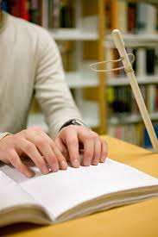
One small example. A student came to me during the summer to gain Braille skills. He had been low vision trying to “do Braille” but poor vision gives poor speed. He had learned most of the alphabet and a handful of contractions, but could not read Braille at all and had a difficult time remembering how to braille in general. I told him to close his eyes and feel...his fingers tuned in as his poor vision tuned out. I had him place his fingers over top of mine as I placed my hands on the Braille sheet of words. I slowly moved my hands in the “butterfly” motion, which I call it, because your hands glide together across, split a few words in, and the right hand finishes the sentence and the left hand begins the next in a smooth floating motion...just like a butterfly. I increased the speed so he could feel the gentle and easy movement across the page. He had no idea it was that easy.

I told him he would be reading Braille by the end of summer if he would commit at least an hour, but I asked for 2 hours a day...Ok, I know in my head, what teenage boy is going to read for 2 hours a day in the summer, or really ever?...but I put it out there. I know with even a minimal amount of effort he can do it with the next method I use.
He first begins with brailing. He only braille’s about himself. His life. What he likes or does not like. I have him braille 3-4 rows of the exact same words in a sentence, using all contractions. He first tells me the sentences he wants to use. I pick out all the contracted words and have him braille these first, over and over until his fingers start to flow. Then I have him braille the sentences. Example. I like to fish. (he will braille that for 3-4 rows--sometimes more depending on the ability of the child’s learning patterns). Next row. I like to fish with my dad.

I have him use 11 x 11 paper, so really, only those 2 sentences fit on a page. He takes out what he has just brailed and positions his hands on the braille paper. At first, I need to help him read the page. However, by the second reading he can do it almost independently. Before he goes home for the day, he has his braille sheets to practice for the next couple of days along with flash cards of brailled words that he had difficulty with in reading.

There are a couple things going on here. I need him to get the flow of his hands reading well so he cannot be struggling with reading the braille. That is where we get all those bad habits from; scrubbing the braille, flying fingers, 1 handed reading. The reading must be easy at first and if it is about the person, they remember. With the constant repetition of the words, he begins picking up the feel of the contraction and the word and flows through the page.

By the end of the summer, as in 2 months, he was reading Braille at 32 words per minute and he only practiced reading about 3 hours a week. On his final day of testing his skills, I asked him, “Are you surprised at how fast you can read Braille?” Very matter of fact, he said “No, you told me I could, so I expected it.”

When he went back to his school, he emailed me and told me his teacher was very impressed with his braille reading ability, both ability to read it, but read it with a beautiful 2 handed flow.

Fellowship of Australian Writers National Literary Awards
Source: http://writers.asn.au/wp/2014/09/faw-national-literary-awards-open-now-2/


Students are invited to enter the FAW 2014 National Literary Awards. Students can win cash prizes and recognition for their writing in one of the many prose and poetry award categories for young writers. For example, the FAW Ivy Hart Award for Rhyming Poetry about Peace or the Environment can be entered by primary-aged students for free. There are also award categories for anthologies by individual students and groups of students. Discounts are available for multiple entries. The Awards close on November 30.

Further information and entry forms are on the writers website: http://writers.asn.au/wp/

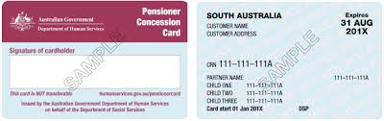
Was your Centrelink pension card issued between the 1st August and the 3rd September 2014? If so, read on…

The BCA National Office received a number of complaints throughout August from members regarding their Centrelink Disability Support Pension (Blind) cards. It was reported that pension cards no longer had the word blind on them; and that the cards were issued without the hole punch in the bottom right hand corner. This was a mistake due to a change of DHS printing contractors, which has now been rectified.

For members issued with a pension card between 1st August 2014 and the 3rd September 2014, you may have encountered this mistake. For members who have received their cards after this date, please check your card to make sure it is correct.
The Department of Human Services advises that these cards will not be automatically reissued, however you can request a new pension card by calling the Department of Human Services Disability and Carers Line on 13 27 17.

BCA membership, only $20 for lifetime membership!


Blind Citizens Australia is the united voice of blind and vision impaired Australians working to achieve equity and equality, positive community attitudes and accessible services that meet our needs.
Our Board, National Policy and Development Council, local branches and individual members identify and address issues through:

• Individual advocacy,
• Systemic advocacy,
• Peer support, and
• Provision of information.

Blind Citizens Australia provides:
• Information and Referral support
• Regular newsletters and audio magazines
• Website: www.bca.org.au , a facebook page, twitter account and email lists
• Newsletter for parents, ‘Parent News’.

Types of Membership
• Full Membership - legally blind Australian residents 18 years and over.
• Junior Membership – legally blind Australian residents under 18 years of age.
• Associate Membership - people who are not legally blind.
• Organisational Membership - for details contact BCA.

There is a membership form available on the BCA website, or you can Complete the attached membership form and return with a $20 lifetime membership fee to:

Blind Citizens Australia,
Level 3, 247-251 Flinders Lane
Melbourne Vic 3000

Or email to bca@bca.org.au

A Membership Registration Form has been included at the end of this newsletter for your convenience.

Do you have an idea for a story which could be published in the next edition of Parent News? We would love to hear from you! Anything from your own personal experience as a parent or teacher of children who are blind or vision impaired that you would like to share with other parents, any tips and hints, upcoming events or equipment solutions? Please send your ideas to bca@bca.org.au with the heading ‘parent news article’ or call BCA’s National Office on (03) 9654 1400 or free call 1800 033 660.

Get the Word Out!
Do you know of a parent, visiting teacher, aide, government department or individual who should be receiving Parent News? Ask them to call us and we’ll make sure that they are on the receiving end of this publication! We are happy to provide Parent News in standard print, email, on audio CD, as a data CD or in Braille.

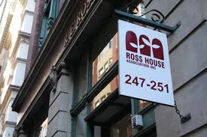

Contact us
Blind Citizens Australia
Ross House Level 3
247-251 Flinders Lane
Melbourne Vic 3000
Phone: (03) 9654 1400 or free call 1800 033 660
Fax: (03) 9650 3200
Email: bca@bca.org.au
Website: www.bca.org.au


https://www.facebook.com/BlindCitizensAustralia


@au_BCA

Disclaimer:
Blind Citizens Australia does not invite reliance upon, nor accept responsibility for the accuracy, completeness or up-to-date nature of the information contained in this newsletter. Readers should confirm information from another source if it is of sufficient importance for them to do so.

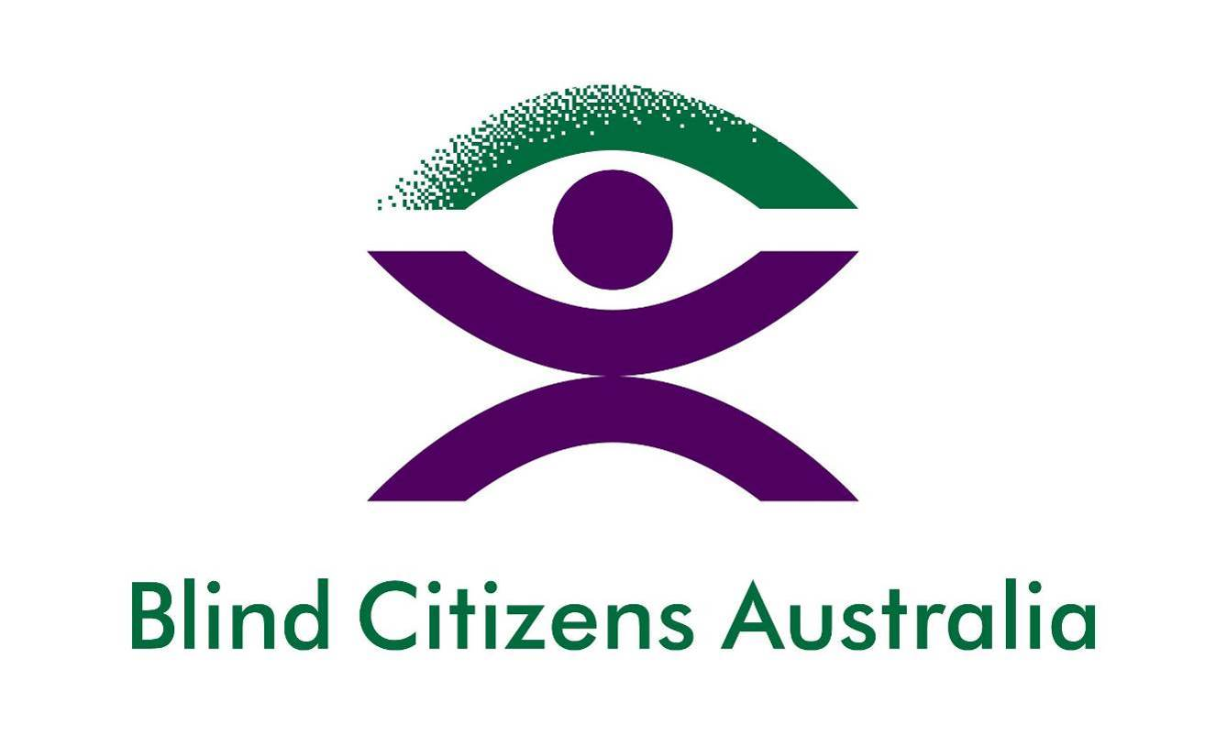

Membership Registration Form

I wish to join as: Full member  Junior member  Associate member 

Mr / Mrs / Miss / Ms

Surname:

Given Names:

Postal Address:

State: Post Code:

Contact Details:
(Home phone)

(Business phone)
(Mobile phone)
(Fax)
Email:

Date of Birth: (Day) (Month) (Year)

I am: Legally Blind  Vision-impaired  Fully sighted 

I have a hearing impairment: Yes  No 

I am of Aboriginal/Torres Strait Islander descent: Yes  No 

My preferred language is: English  Other:_______________________

I would like to receive Blind Citizens News in:
Email  Data CD  Braille  Audio CD  Large print 

I would like to receive Soundabout, audio magazine via:
(Note this is an interview magazine)

Email notice that files are available on the website  Audio CD 

I would like to receive all other material in:
Email  Data CD  Braille  Audio CD  Large print 

Please send me information on Special Interest Groups:
Womens Branch 
Computer Users Group 

Enclosed is my cheque / money order (or)

Charge my: VISA / MASTERCARD For $20.00

Cardholder's Name:

Card Number:

CCV:

Expiry date: / /

Signature:

Please note that until a cheque or money order is received membership applications will not be processed.

Please return completed form to:

Blind Citizens Australia
Level 3, 247-251 Flinders Lane
Melbourne Vic 3000

Or email to: bca@bca.org.au

Alternatively, you can call the BCA National Office on 1800 033 660 or 03 9654 1400 and we can conveniently complete the forms for you over the phone.

