Identifying Australian Banknotes

Australian banknotes can be identified by sight and by touch.

Sight

Australian banknotes can be identified by the bold numbers in the top right hand corner and also by their colour. Make sure that you have enough light to see the numbers and colours properly.

$100 note = mostly green
$50 note = yellow
$20 note = reddish tones
$10 note = blue
$5 note = pinkish/purple

Touch

In Australia the notes become longer as they increase in value. The five dollar note is the shortest note, and the one hundred dollar note is the longest.

As of October 2019, tactile raised bumps have been included on the long edge of the ‘next generation’ versions of the $5, $10, $20 and $50 bank notes, to distinguish between different denominations of bank notes.

$50 note = four raised bumps
$20 note = three raised bumps
$10 note = two raised bumps
$5 note = one raised bump

It is expected that the $100 banknote will be released in 2020, with the same features.

The Cash Test Card

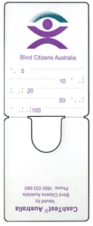
Image of Blind Citizens Australia Cash Test opened

Front of card:

The front of a cash test card has a colour image of the BCA logo at the top. The words “Blind Citizens Australia” are written underneath the logo.
Below this are five horizontal lines of raised dots and alternating on either side of the raised dotted lines are written the numbers five, ten, twenty, fifty and one hundred in Braille.
The fold is at the lower edge of the front of a cash test card.

Back of card

The back side is the shorter side of the cash test card with the fold at the lower edge and a thumb hole for gripping a banknote half way along the fold.

Using the Cash Test Card

Place an Australian banknote in the centre fold and fold it over to the front of the cash test card. Hold the banknote firmly in place by gripping the banknote through the thumb hole at the back of the card.
The note will reach a line of raised dots on the front of the cash test card as described earlier.
The top line of raised dots marks the placement of the edge of the five-dollar note.
The second line of raised dots marks the placement of the edge of the ten-dollar note.
The third line of raised dots marks the placement of the edge of the twenty-dollar note.
The fourth line of raised dots marks the placement of the edge of the fifty-dollar note.
The bottom line of raised dots marks the placement of the edge of the one hundred-dollar note.

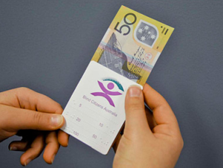
Blind Citizens Australia Cash Test and $50 note

The Cash Test Card is provided through Blind Citizens Australia by the Reserve Bank, and is available to people who are blind or vision impaired, at no cost. If you would like a Cash Test, please contact Blind Citizens Australia and we will post one out to you.

