Level 3
Ross House
247-251 Flinders Lane
Melbourne Victoria 3000
Telephone: 03 9654 1400
Toll Free: 1800 033 660
Fax: 03 9650 3200
Email: bca@bca.org.au
Website: www.bca.org.au

Blind Citizens Australia ABN 90 006 985 226. Gifts are Tax Deductible.

Blind Citizens Australia

Media Release

Australia Takes Landmark Step Towards TV for All

After twenty-five years of campaigning, people who are blind or vision-impaired will finally be able to enjoy television with family and friends when Audio Description (AD) is launched by Australia’s public broadcasters, the ABC and SBS, on 28 June.

AD is a verbal narration which describes actions, scenery, costumes and other visual elements to make television accessible to people who are blind or vision impaired. It is available on some streaming services; however, until now, Australia was the only English-speaking OECD country not offering AD on free-to-air television.

Emma Bennison, CEO of Blind Citizens Australia (BCA), welcomes the introduction of AD and acknowledges the commitment of the Australian Government to funding its implementation.

“We thank Minister for Communications, Paul Fletcher, for enabling us to watch TV, a basic human right that we have been denied for too long.”

Rosalie O’Neil, of Sale, Gippsland, Victoria, is vision impaired and lives with severe osteoarthritis.

“TV is a low-cost, low-energy activity for me as sometimes I can’t see or walk around. Audio Description opens up accessibility to people with low vision, blind[ness], seizures, autism, movement difficulties, learning difficulties and social difficulties.”

BCA, in conjunction with other blindness organisations, has campaigned for AD since 1996, championing the right of people who are blind or vision impaired to watch television with family and friends. “We celebrate this life-changing milestone,” Ms Bennison said.

“BCA and other blindness organisations have worked closely with both the ABC and SBS to facilitate the rollout of AD. We acknowledge and thank them for their strong commitment to providing a quality service that will meet the needs of Australians who are blind or vision impaired. Our community looks forward to confirmation that AD will be a permanent fixture on Australian television beyond this current twelve-month funding period.”

“BCA also looks forward to AD being enshrined in legislation, in the same way that captioning is for Australians who are Deaf or hard of hearing. With the support of other blindness organisations, Australians who are blind or vision-impaired and the general public, we will continue to advocate for permanent AD services on all Australian TV outlets.”

For more information, please contact:

Kathie Elliott
Media - Blind Citizens Australia
Phone: 0439 724 304
Email: kathie.elliott@bca.org.au

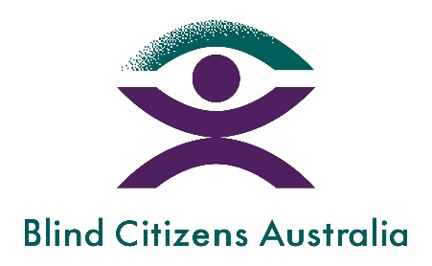

The Sector Working Group on Audio Description includes representatives from (and logos listed above in alphabetical order):
Australian Communications Consumer Action Network (ACCAN)
Blind Citizens Australia
Centre for Inclusive Design
Curtin University – Centre for Culture and Technology
Guide Dogs Australia
Royal Society for the Blind (RSB)
The SubStation
Vision 2020 Australia
Vision Australia

Background Info
Who is Blind Citizens Australia?

Blind Citizens Australia (BCA) is the national representative organisation of people who are blind or vision impaired.

Our mission is to inform, connect, and empower Australians who are blind or vision impaired and the broader community.

For additional background information please visit our website, https://www.bca.org.au

Please let us know if you’d like this information in another format for accessibility.

