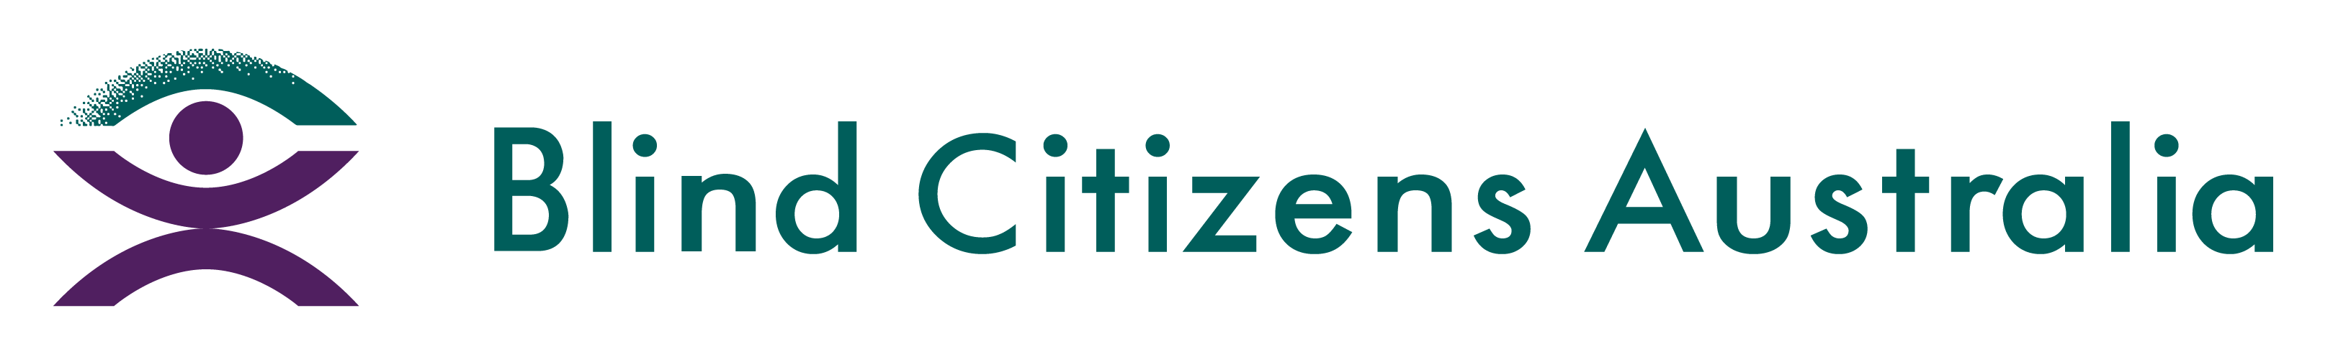
Ph 1800 033 660 | E bca@bca.org.au | W bca.org.au | ABN 90 006 985 226

Dear New South Wales Electoral Commission,
Blind Citizens Australia is the national representative organisation of people who are blind or vision impaired.
The purpose of this letter is to express our great concern about the recent decision to decommission the iVote system for future elections, including the New South Wales State Election in 2023. We believe this decision infringes on the rights of people who are blind or vision impaired to partake in the electoral process by removing the only existing accessible voting mechanism to ensure an independent, secret, and verifiable vote for our community.
The ability to cast an independent, secret, and verifiable vote is a fundamental right, upheld by the principle that all Australians must be able to freely and equally participate in the political process. This is one of the foundational principles of democracy, and forms part of Australia’s commitment in ratifying the United Nations Convention on the Rights of People with Disability. By removing the access provided through iVote, the New South Wales Electoral Commission is failing to provide a platform for people who are blind or vision impaired to cast a secret and verifiable vote, and failing in its commitment to the CRPD.
Any other form of voting, such as via telephone, does not fulfill the necessary accessibility requirements and provides no guarantee or confidence to the blind and vision impaired community that their vote will be secret and verifiable. Concerningly, the suspension of iVote reintroduces discrimination in access to elections for blind and vision impaired citizens, and may constitute unlawful disability discrimination under both the Disability Discrimination Act 1992 (Cth) and the Anti-Discrimination Act 1977 (NSW).
We are also concerned about the Government’s failure to consult with our community in the making of this decision. As the only mechanisms available for people who are blind and vision impaired to fulfill their right to an independent, secret, and verifiable vote, BCA has strongly advocated for the continued expansion and development of iVote since its inception in 2011. Its discontinuation will greatly impact how our community participates in elections. The decision to decommission it’s use altogether was made hastily and without input from people who are blind or vision impaired or their representative organisations.
Failing to have an election process that is accessible to all residents has the potential to result in the formation of a government that does not reflect the needs, interests, and values of the residents it represents. The failure to consult further disenfranchises our community and excludes our voices from the electoral process.
For these reasons, we call on the New South Wales Electoral Commission to:
- recall its decision to decommission iVote;
- reinstate the platform for voters who are blind or vision impaired; and
- guarantee the platform will be available to blind or vision impaired voters for the NSW State Election in 2023.
Finally, we urge the Electoral Commission and New South Wales Government to create a secret, independent, verifiable voting platform that allows for a multifaceted approach to voting and balances access and security equally. We seek a commitment that consultation with our community will occur during the development of said platform, to ensure it is fit for purpose.

