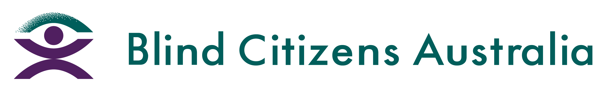
Ph 1800 033 660 | E bca@bca.org.au | W bca.org.au | ABN 90 006 985 226

Receiving Information in an Accessible Format
September 2023
The National Disability Insurance Agency (NDIA) will not automatically provide you with information in an accessible format.
During your planning meeting you will need to tell your Planner or Local Area Coordinator if you would like to receive a copy of your plan in one of the following formats:
- Braille
- Large Print
- Electronic Text (on a CD)
- Audio (on a CD)
The National Disability Insurance Agency has stated you will receive your plan within 7 days of its approval in your chosen format. You will also receive a standard print copy of your plan in the post once it is approved.
For any other documentation you receive, such as letters, you will need to call the National Disability Insurance Agency or your Local Area Coordinator and advise that you need the letter resent to you in an alternate format. The National Disability Insurance Agency has not provided a time frame on how long this process will take.
Because the National Disability Insurance Agency does not provide alternate formats automatically you will need to advise them of your request every time your plan changes or every time you receive correspondence from them.
Having your documents provided in alternate formats will not cost you any money and funding will not be taken from your plan to provide this service.
To request documents in an accessible format, you can contact the National Disability Insurance Agency by:
- Calling the National Disability Insurance Agency on 1800 800 110 (Monday – Friday 8:00am – 11:00pm)
- Speaking to someone in person at your local office
- Sending an email to enquiries@ndis.gov.au
- Writing a letter and send it to National Disability Insurance Agency PO Box 700 Canberra ACT 2061
If you have difficulty receiving your plan or any other information in a format that is accessible to you, please contact BCA for further advice and support.

