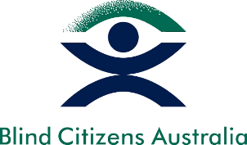
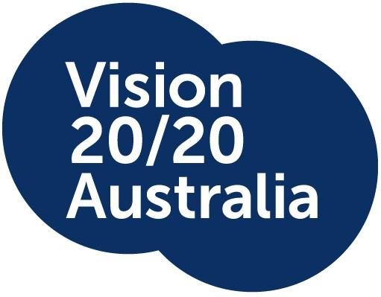

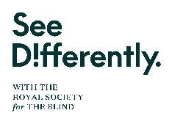

Joint Statement
Monday, December 11, 2023

Blind and low vision sector supports NDIS Review recommendations
Vision 2020 Australia and Blind Citizens Australia (BCA) welcome the release of the NDIS Review and support the proposed next steps to ensure the NDIS and broader system supports deliver equitable access and participation for people with disability.
This position is also supported and endorsed by the following Vision 2020 Australia members: Vision Australia, Guide Dogs Australia, See Differently (with the Royal Society for the Blind), and Macular Disease Foundation Australia (MDFA). All these organisations provide critical services to people who are blind or have low vision.
Australia should be proud to have introduced and implemented a world first Scheme that supports people with disability. But as the Minister for NDIS, the Hon. Bill Shorten MP acknowledged, the NDIS has become “the only lifeboat in the ocean”. One of the Review’s key recommendations is foundational supports for people with disability, whether or not they’re scheme participants. “These supports will create a continuum,” the Minister said, “so there would not be so much of a focus on being in or out of the NDIS.”
There are many people whose vision loss prevents them from holding a driver’s license, who are nonetheless considered “not disabled enough” to access the NDIS. The introduction of foundational supports may provide a crucial source of funding for people whose needs are more episodic.
We’re also pleased to see the Review’s focus on improving outcomes for young children. We hope that a combination of foundational supports, an improved access pathway, a focus on addressing developmental concern, and capacity-building for families will all lead to better outcomes for young children.
Outside the NDIS, assistive technology is funded through various state-based schemes, all with different funding and eligibility criteria. For years we’ve been working with the Assistive Technology for All Campaign to advocate for a simpler system that is easier to navigate and gives people the equipment they need quickly and efficiently. It’s great to see the Review acknowledge this need.
Transport is another key area where NDIS participants who are blind or have low vision have dealt with a lot of confusion and uncertainty, with some states threatening to cut off hugely beneficial taxi subsidy schemes, and transport funding through the scheme often inconsistent and insufficient. We welcome the recommendation for a new mobility policy that would prioritise ensuring people who are unable to drive still have access to education and employment.
But the issue most often raised by people who are blind or have low vision is the inequity in the planning process. We welcome the Review’s focus on improving access and planning but are concerned about the proposed needs assessment process. If such a process were to be effective, it would need to be developed through the collaboration and co-operation the Minister promised. But we think making plans much more flexible, and giving people the choice and control to use their funding for the supports that will help them, is a valuable and much-needed step in the right direction.
Vision 2020 Australia CEO, Carly Iles, welcomed the comments from the Minister for NDIS, the Hon. Bill Shorten MP, that the reforms will be implemented through collaboration and cooperation.
“I look forward to working with state and federal governments to ensure equitable access and inclusion are upheld for the low vision and blind community,” Ms Iles said.
BCA CEO, Deb Deshayes, said she is thankful for the NDIS review panel’s efforts in engaging the advocacy sector, and people with disability in this important review.
“We acknowledge those who contributed by participating in the consultations, and sharing their experiences, feedback and views,” she said.
“The sector promotes that this level of engagement continues in the next phase of the government’s consideration, response and implementation of the review’s recommendations.”

-ENDS-

Media contact:
Kevin Rigby, Communications Manager, Vision 2020 Australia
0437 460 739
krigby@vision2020australia.org.au

Amila Dedovic, Communications Coordinator, Blind Citizens Australia
0403 967 406
amila.dedovic@bca.org.au

About the NDIS Review
On December 7, 2023, the Independent Review of the NDIS released its final report. Its publication follows an agreement by National Cabinet to change the way the NDIS is funded, and to introduce foundational supports to be accessed by people with disability outside the scheme.
The review offers 26 recommendations, and 139 supporting actions. The final report makes clear that these recommendations are all equally important, and should be adopted as a package.
Members of the panel, alongside the Minister, will be delivering town hall briefings on the Review over the coming days. Register to attend Sydney or Melbourne events. A Brisbane event is also planned.
About Vision 2020 Australia
Vision 2020 Australia is the national peak body for the eye health and vision care sector, representing over 50 member organisations involved in local and global eye health and vision care, health promotion, low vision support, vision rehabilitation, eye research, professional assistance and community support.

About Blind Citizens Australia
Blind Citizens Australia (BCA) is the national representative organisation of people who are blind or have low vision. Their purpose is to inform, connect, and empower Australians who are blind or vision impaired and the broader community.

