Quantum is a 100% Australian-owned company that has been providing services and products to people in Australia with a vision impairment for more than 35 years. We are an approved supplier to DVA, NDIS and My Aged Care.

Contact us on 1300 883 853 to make an appointment, no referrals are necessary. You can also check out our [website](https://www.quantumrlv.com.au/): [www.quantumrlv.com.au](http://www.quantumrlv.com.au/)



[**ZoomText Fusion**](https://www.quantumrlv.com.au/products/zoomtext-fusion-professional?_pos=1&_sid=b0d4a8197&_ss=r)

ZoomText Fusion is a fully integrated magnification and screen reading program that enlarges, enhances and reads aloud everything on the computer screen. Try Fusion out in 40 minute mode, download now from our [website](https://www.quantumrlv.com.au/pages/4f7c92e1b0a3487f8d9a1c6b3e3f82a7).

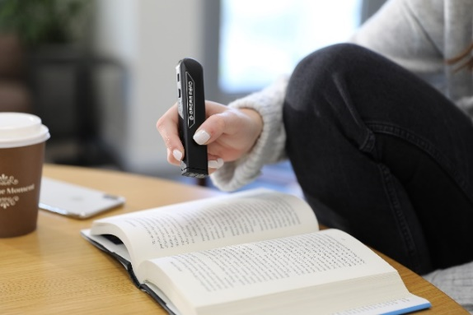

[**OrCam Read Lite**](https://www.quantumrlv.com.au/products/orcam-read-lite?_pos=1&_sid=e36c92a7b&_ss=r)

This compact, hand-held device reads text aloud with just a simple point and click, instantly capturing words from nearly any printed surface or screen. Whether you to read a page, a single paragraph, or even signage at a distance, the OrCam Read Lite offers an intuitive and seamless reading experience that sets it apart from traditional reading aids. Watch the OrCam Read Lite video on [Youtube](https://www.youtube.com/watch?v=FtfOCFO8CKA).

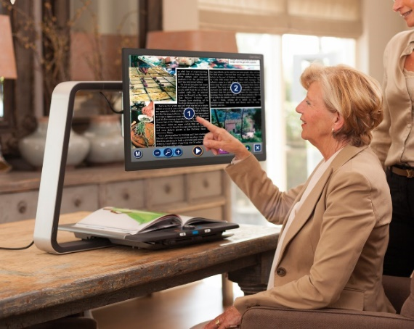[**ClearView WideView Speech**](https://www.quantumrlv.com.au/products/clearview-c-speech-24-high-definition?_pos=2&_sid=ba4863c9a&_ss=r)

The ClearView C24 Wideview Speech is a unique desktop magnifier designed to improve your reading experience. It allows more working space and helps you to read your favourite newspaper, enjoy hobbies or manage other tasks without being restricted in movement. The ClearView C24 Wideview Speech can instantly convert any printed text into speech.

**1300 883 853** | [**www.quantumrlv.com.au**](http://www.quantumrlv.com.au) **| Showroom locations below**

Sydney: 1/2 Pioneer Avenue, Thornleigh NSW 2120

Melbourne: 6/417 Ferntree Gully Road, Mount Waverley VIC 3149

Brisbane: Suite 603 Lvl 6, Ladhope Chambers, 131 Wickham Terrace, Spring Hill QLD 4000