

Blind Citizens Australia
July 2024 - June 2025
Year in Review

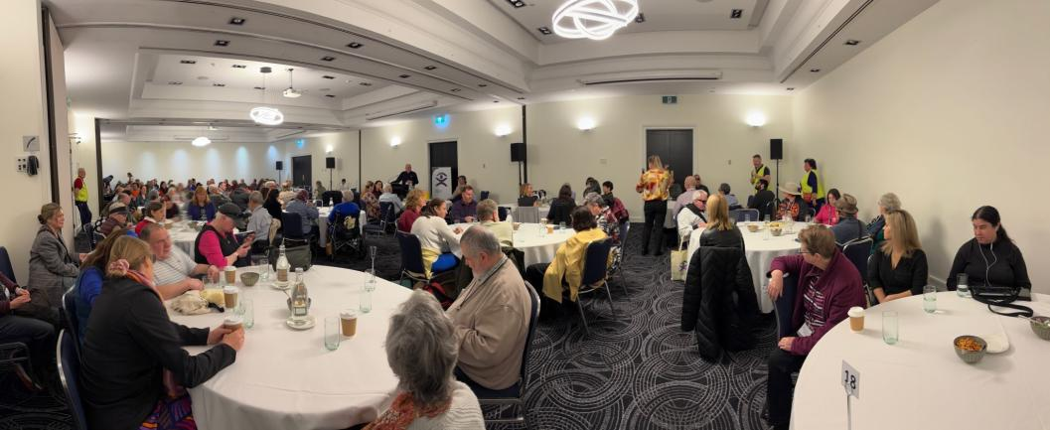

Cover Image Description: A panoramic image of the BCA ballroom for the 50th Anniversary Convention. Six tables can be seen in the image, with dozens of people seated for a session.

Mailing Address:
247-251 Flinders Lane Melbourne Victoria 3000
Tel: 1800 033 660 SMS: 0436 446 780
Email: bca@bca.org.au Website: www.bca.org.au
ABN: 90 006 985 226

Blind Citizens Australia (BCA) is the National representative organisation of people who are blind or vision impaired.

Our purpose is to inform, connect, and empower Australians who are blind or vision impaired and the broader community.

BCA acknowledges the traditional owners of the land where we work and live. We pay our respects to elders past, present, and future and celebrate their stories, culture and traditions.

Table of Contents
Blind Citizens Australia July 2024 - June 2025 Year in Review 1
Mailing Address: 2
Table of Contents 3
Overview 5
Staffing 6
Sustainability and Growth 9
How we Informed 13
BCA Websites 13
Social Media 14
BCA in the Media 15
Member Engagement 17
How we Connected 21
Events 21
Peer Connect Groups 25
International Work 26
Branches 29
External Representation 29
How We Empowered 37
Individual Advocacy 37
National Policy Committee (NPC) 38
BCA’s Work in New South Wales 38
BCA Hugh Jeffrey Scholarship 41
Campaigns 41
Submissions 44
BCA Projects 45
Feedback 48
Closing Remarks 48
The BCA Team 2024 to 2025 49

Overview
The 2024-25 financial year marked a significant milestone for BCA, celebrating 50 years of advocacy, community, and growth. This landmark year was highlighted by the successful return of the National Convention. Delivered as a hybrid event, it brought together over 150 members to reflect on the organisation’s history and explore future directions.
Organisationally, BCA underwent a restructuring in response to a significant decrease in our government funding for the financial year. The restructuring resulted in a decrease of staff numbers and the team worked hard to ensure members remained supported and informed. Amid these changes, the Eye to the Future project was extended until 30th June 2025, allowing us to continue supporting meaningful employment opportunities for people who are blind or vision impaired.
Governance saw important changes with the resignation of President Fiona Woods in September 2024. We acknowledge her significant contributions over eight years as both Director and President.
Vaughn Bennison was elected as President, along with three new directors at the Annual General Meeting, reflecting a renewed focus on member engagement and leadership.
In 2024–25, BCA continued to represent the rights and interests of people who are blind or vision impaired through timely policy responses and individual advocacy. BCA also supported members in understanding the impact of major political events, publishing resources around state and federal elections and offering analysis on the outcomes and implications for our community. Other focus areas included accessible health services, digital accessibility, and regular updates on reforms to the NDIS and the findings of the Disability Royal Commission. BCA’s policy and advocacy efforts continued to influence national disability reforms and advance the interests of people who are blind or vision impaired.
Together, these developments positioned BCA for continued connection and influence as it moves beyond its 50th year, with a strong commitment to empowering members and shaping an inclusive future.

Staffing
Over the 2024 to 2025 financial year, BCA employed 12 staff, and 3 contractors of which 6 are blind or vision impaired, have lived experience, or have disability.
Deb Deshayes has served as CEO throughout the 2024-25 financial year. Under her leadership, BCA successfully organised its first in person convention in six years, marking a significant milestone: the celebration of BCA’s 50th anniversary. Held in Glen Waverley, Melbourne, the convention saw a strong in-person turnout, with more than 150 members coming together to connect, reflect and celebrate this important occasion.
The CEO works closely with the board to shape and implement BCA’s organisational strategy. In addition to representing BCA on government access committees, Deb builds and maintains strong relationships with partner organisations, the broader disability sector and key stakeholders. The role also includes oversight of finance, risk management, IT support and the coordination of all national events.
During the financial year, BCA onboarded a Fundraising Manager to focus on increasing the fundraising capacity of BCA and the Jeffrey Blyth Foundation. The role, supported by the Jeffrey Blyth Foundation, leads and develops operational strategy that generates untied income, including strengthening BCA’s donations, bequests and wills, sponsorships and access to philanthropic funds.
As outlined in the Constitution, the role of Company Secretary continues to be jointly held by the CEO and the General Manager Operations.
Angela Jaeschke, BCA’s General Manager Operations oversees the Policy and Advocacy, Projects and Engagement, as well as the Communications and Administration.
BCA extends its deepest gratitude and commendation to its dedicated staff, valued contractors, and committed volunteers. Their unwavering dedication and tireless efforts throughout the 2024-25 financial year were critical to the organisation’s milestones and overall success.
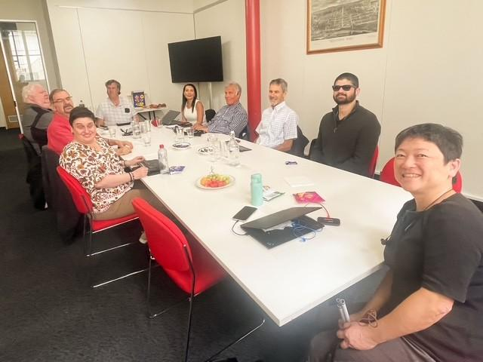
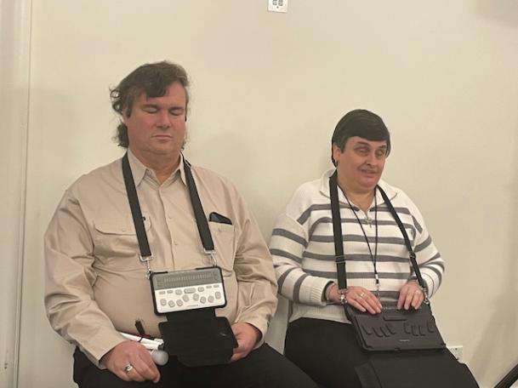
Image description: The BCA Board gathered around a table, smiling to the camera. Left to right: Helen Freris, Garry Adler, Neale Huth, Vaughn Bennison, Deb Deshayes, BCA CEO, Stefan Slucki, Andrew Webster, Raj Reddy and Lee Chong.
Image description: Vaughn Bennison, BCA President, and Helen Freris, BCA Vice-President, sat next to each other.

Sustainability and Growth

Funding and finance
BCA continued to convene the Finance, Audit and Risk Management (FARM) committee this financial year, overseeing BCA’s finances and investments. BCA acknowledges and thanks Chair Andrew Webster for his significant contributions in chairing the FARM committee.
We would also like to extend our thanks to the committee for their oversight and ongoing contributions. A full list of the FARM committee members can be found in the BCA Team section.
Full details of BCA’s finances and the Independent Auditors Report are contained in our "Financial and Audit Report 2024 to 2025" available on our website, or in your preferred format on request.

Funding partners
BCA would like to thank and acknowledge the following departments, organisations and individuals for their support and commitment to the work of BCA:
Jeffrey Blyth Foundation
Shirley Fund
Vision Australia
Guide Dogs Australia
Guide Dogs NSW/ACT
EverAbility
Department of Social Services (DSS) for Eye to the Future Project
National Disability Insurance Agency (NDIA)
Department of Social Services (DSS) via AFDO Consortium
NSW Government through the Department of Communities and Justice
Victorian Government through the Department of Families, Fairness and Housing (DFFH)
Maxwell Lennon bequest
Sponsors of BCA’s 50th Anniversary Convention
BCA Backers – members who make regular monthly donations
Members who donated in response to BCA member appeals

Partnerships and collaborations
During the year, the board maintained its strong commitment to building and maintaining strategic relationships.
BCA continued to collaborate with partner organisations in the blindness sector, meeting with the CEOs and their representatives, to work towards a common aim of upholding and enhancing the rights of people who are blind or vision impaired.
BCA also maintained and developed collaborations with the broader blindness sector, disability sector, and beyond. Below is a list of BCA’s partnerships and collaborations:
Vision Australia
Guide Dogs Australia
EverAbility
Jeffrey Blyth Foundation
Vision 2020 Australia
Macular Disease Foundation Australia
Retina Australia
Blind Citizens New Zealand
Orthoptics Australia
Sensory Access Australia
Australian Federation of Disability Organisations (AFDO)
Australian Communications Consumer Action Network (ACCAN)
Disability Representative Carer Organisations
World Blind Union
Roundtable on Information Access for People with Print Disability
Disability Advocacy Victoria
Justice and Equity Centre
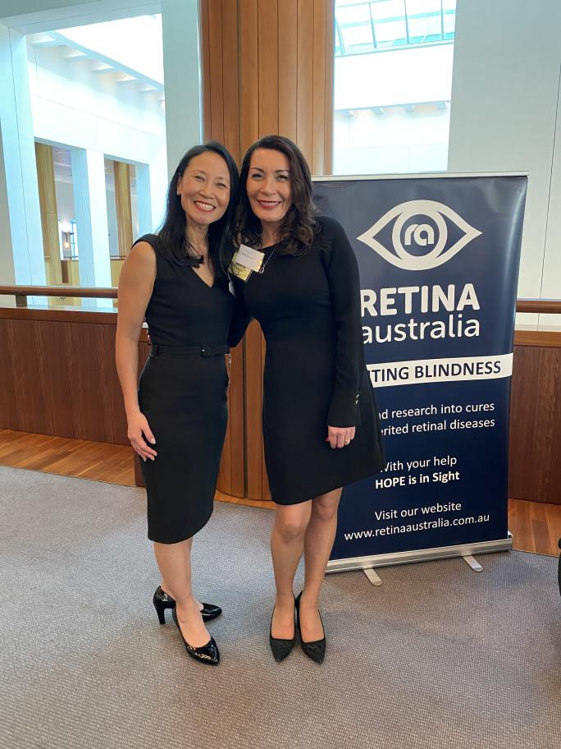
Victorian Chamber of Commerce and Industry
Image description: Julia Hall, Retina Australia CEO, and Deb Deshayes, BCA CEO, standing together and smiling. Behind them is a Retina Australia banner.

How we Informed
We continued our commitment to providing high-quality, accessible information that meets the needs of our members as demonstrated by the following highlights:

BCA Websites
BCA’s websites continued to provide updated information, resources and updates to members and the wider community.
BCA’s main website www.bca.org.au includes information about Blind Citizens Australia and its policy and advocacy work. It also includes information on how members can get involved with BCA, as well as including BCA publications and event recordings, and hosting the New Horizons podcast.
BCA’s website had 24,300 active users over the year.
BCA’s An Eye to the Future website www.eyetothefuture.com.au includes career resources for jobseekers who are blind or vision impaired, as well as employer resources to change perceptions and highlight the skills, knowledge and diversity that people who are blind or vision impaired bring to the workplace.
An Eye to the Future website had 3,600 active users over the year, with the vast majority from Australia (80%), followed by the US (10%) and the UK (2%).

Social Media
All of BCA’s social media platforms have continued to grow throughout the past twelve months. We engage with our members through social media to promote BCA events, post updates on our advocacy and policy work, as well as to build awareness in the broader community on a range of policy and advocacy issues.
Our LinkedIn page has been used more frequently this year to promote workplace inclusion and accessibility to employers and businesses, including promoting BCA’s An Eye to the Future project which supports employers to expand and diversify their workforce, as well as regular posts from our CEO highlighting key networking and engagement activities across the sector. As a result of these increased activity, BCA’s LinkedIn page also saw an increase of 100 followers, representing a 19% increase and bringing the total to 615 followers.
BCA’s Facebook page had a reach of 23,600, which was up 8% from the previous year and an increase of 78 followers.
Below are the links to follow BCA on social media:
BCA on Facebook
BCA on X (formerly Twitter)
BCA on LinkedIn
BCA on YouTube

BCA in the Media
Throughout the year, BCA has maintained a strong and impactful presence across various media platforms, using these opportunities to advocate for systemic change, share community stories and celebrate our 50th Anniversary.

Advocacy & Funding Cuts
In July 2024, BCA was featured in national discussions about the impact of government funding cuts on disability advocacy services:
- ABC News reported on disability organisations being "on life support", with Deb Deshayes, BCA CEO, highlighting the real-world consequences of reduced funding - ranging from service cutbacks to limited capacity for policy engagement.
- At the state level, BCA joined 14 other organisations in urging the Victorian Government to provide urgent gap funding to meet increasing service demands - this joint advocacy was featured in coverage of the 2024 Victorian Budget response.

Discrimination & Access Rights
During the period, BCA shared a member's story to highlight ongoing issues with public transport discrimination. A media release crafted by us shared the story of Debra Simons, a BCA member who is blind and was repeatedly refused service by 13cabs drivers. This led to a feature article in The Guardian, where BCA National Advocacy Officer Martin Stewart provided broader context on the systemic nature of dog guide refusals and the limitations in the current complaints process.

Accessible Education
In February, BCA announced the opening of the 2025 Hugh Jeffrey Scholarship Program. The media release highlighted how the scholarship supports students facing accessibility challenges, featuring an interview with law student Samantha Alexander, who shared how the funding helped her upgrade important technology for her studies.

Celebrating Our 50th Anniversary
BCA’s 50th Anniversary and National Convention in June 2025 were major focal points in our media strategy:
We engaged with a broad network of organisations in the sector such as Guide Dogs Australia, Vision Australia, Vision 2020 Australia, Macular Disease Foundation Australia, Retina Australia and others to promote the Convention through newsletters, bulletins and shared platforms.
BCA representatives featured on Vision Australia radio programs:
- Leisure Link with Peter Greco (April 2025): Martin Stewart reflected on the community’s achievements and invited listeners to the Convention.
- Focal Point (May 2025): Jennifer Parry discussed preparations for showcasing music peer group contributions at the event.

Member Engagement
Member engagement is one of our biggest priorities at BCA. The input and collaboration that we receive from our members contribute to the work of BCA both in terms of the content we produce and the services, programs, and events we provide.

Blind Citizens News
Blind Citizens News is BCA’s flagship publication, which is sent to all members in their preferred format.
In 2024-25, two editions of BC News were published: the Spring Edition and the Special 50th Anniversary Edition. In the Spring Edition, we summarised the recent progress of disability reform and covered key policy changes. Fiona Woods also shared reflections on her time as President of BCA, discussing the challenges and highlights of leading a member-based organisation. Personal stories were shared, emphasising people’s experiences with technology and how it has impacted their day-to-day lives.
The Special 50th Anniversary Edition magazine celebrates the rich history of BCA, highlighting how far the organisation has come through personal reflections and reprinted articles that capture key moments in time. This commemorative edition explores the origins of the publication, the development of blindness advocacy in Australia, the founding of BCA and the evolution of technology over the past 50 years. It also shines a light on women’s involvement in BCA and includes stories of members’ experiences attending international events and contributing to global projects. Other featured topics include advocacy for an LGBTQIA+ group within BCA, the experiences of women from diverse cultural backgrounds living with vision loss and issues facing members of the deafblind community.
A special thanks to Lynne Davis, Carmel Jolley, Amy Curran and Susan Thompson for all their work in creating the Special 50th Anniversary Edition.

New Horizons
New Horizons is BCA’s National, weekly radio program and podcast. It covers topics relevant to people who are blind or vision impaired.
Hosted by Vaughn Bennison, New Horizons provided regular updates from BCA on staffing changes, projects, events, branch news, and our advocacy and policy work throughout the year. The program also explored a wide range of topics, including dog guide refusals, airline travel, audio description, and eye research, and featured coverage of events such as the 2025 South Pacific Educators in Vision Impairment (SPEVI) Conference and BCA’s own 2025 Convention.
Since April 2025, the program has been on hiatus while the Board considers the future direction of New Horizons and explores sustainable options to support its continued success and impact. This pause coincided with Vaughn Bennison stepping into the role of BCA President.
Thank you to Vaughn for hosting the segment for nearly a decade and providing the community with important information, engaging interviews and a valuable connection to issues that matter.
New Horizons was broadcasted via the RPH Network and community radio stations across Australia. It is also available as a podcast on BCA’s website and through the Vision Australia Library service.

Member Update
BCA’s Member Update is our weekly newsletter to members containing information about upcoming events and opportunities at BCA and across the sector. With BCA’s focus on member engagement and information sharing, the Member Update is currently circulated to 1,849 people each week who are subscribed to BCA’s announcements email list.
The Member Update includes information and updates on BCA’s projects, branch activities, events, as well as updates from the sector, and information on accessible community events. We know that a lot of our members rely on this weekly update and it’s terrific to see more people subscribe to BCA’s announcements email list each month.

Phone-based information
BCA’s inbound and outbound text messaging service continues to enable members to receive immediate and timely information about current BCA activities and serves as a pathway to provide feedback and ask questions via text message. This is particularly critical for people who are Deafblind or those who have other access barriers.
BCA’s web-based phone system not only facilitates remote working for our staff, but it also provides members and other stakeholders with information about current BCA activities, campaigns and events via the interactive menu. Callers can also provide anonymous feedback via the system.

BCA Inform
BCA Inform is a platform for members to come together each month online to learn about and discuss issues of importance. As well as updates from BCA, guest presenters provided a unique insight to partnerships and work being done to improve access. Between 14 and 30 people attended each Inform event, with a total attendance of 193 in this reporting year. Each session was recorded and available on demand via BCA’s website.
Topics this year included:
What The Election Results Mean For Our Community
Employment
Accessible Health Services
Australian Federal Election
Inclusive and Accessible Procurement
AI and Digital Accessibility
Shaping a Plan for Accessible Information and Communication
Championing Your Voice: Election 2024
NDIS and DRC Update
Consultation On Future Inform Topics
Sports and Community Participation

How we Connected

Events

50th Anniversary Convention
Taking place in Glen Waverley, Melbourne, the 2025 National Convention was a two-and-a-half-day event that brought together members in-person and online to celebrate 50 years of advocacy and community. Helen Freris, BCA Vice-President, and John Simpson AM emceed the event.
This event took a deep dive into BCA’s past and future, starting with stories from the people who helped create the organisation and highlighting key advocacy wins over the decades. It covered current projects focused on employment and self-advocacy, explored the evolving role of support workers, and looked at how AI could impact daily life. Interactive panels and personal interviews gave members the chance to share experiences, reflect on progress and imagine what’s next for the community. Behind the scenes, session chairs and speakers played a key role in making the event informative for all attendees.
A huge thank you to Katrina Taylor, Lynne Davis, Martin Stewart, Rachael Johinke, Michael Janes, Joyce Jones, Ben Clare, Vaughn Bennison, Emma Bennison, Fiona Woods and Graeme Innes AM, who all chaired sessions. We also thank all the speakers, who are listed further below, for delivering engaging presentations that reflected on our past while creating space for members to connect and learn from one another.
This event would not have been possible without the support of the Convention Program Committee, 50th Celebration Committee, Logistics Committee, BCA staff and volunteers.
We also thank the online streaming team including Stephen Jolley, Vaughn Bennison, Jonathan Craig, Lee Kumutat, Paul Price and Steve Ransley-Richardson, who made it possible for members to connect via Zoom and YouTube and tune into the comprehensive two-day program.
A thank you to Dan Stubbs and Katie Butler, who emceed the National Convention dinner, and all of those who contributed to the evening.
Congratulations to John Machin who received the David Blyth Award, Jordie Howell who received the Diana Braun Aspirations Award, and Chire Fulford and Stephen Belbin, who both received the BCA Certificate of Appreciation.
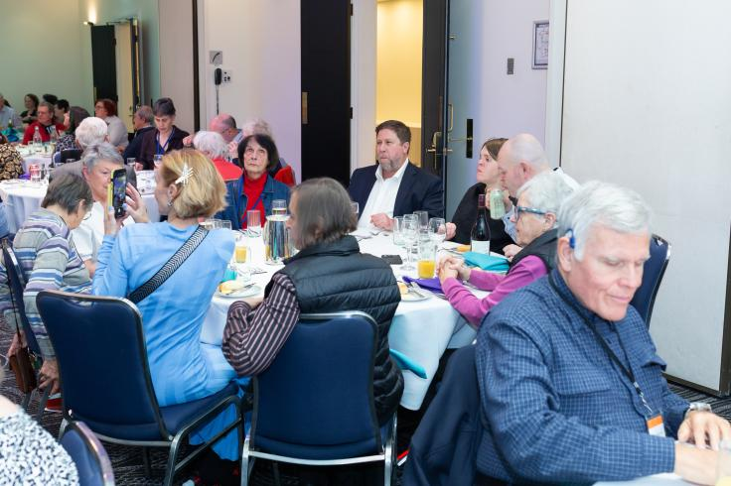
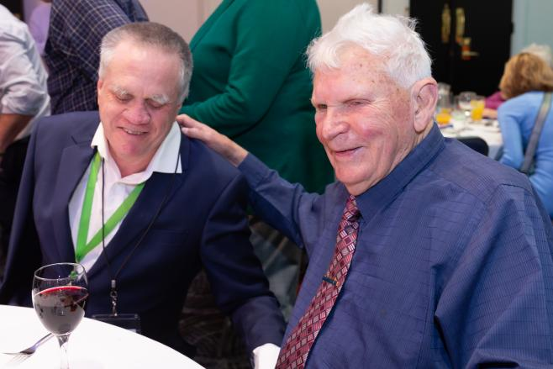
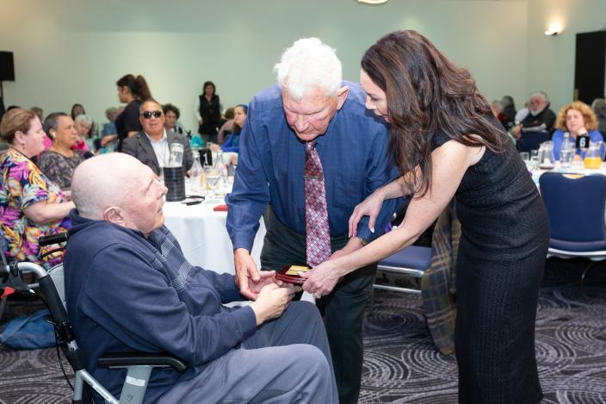
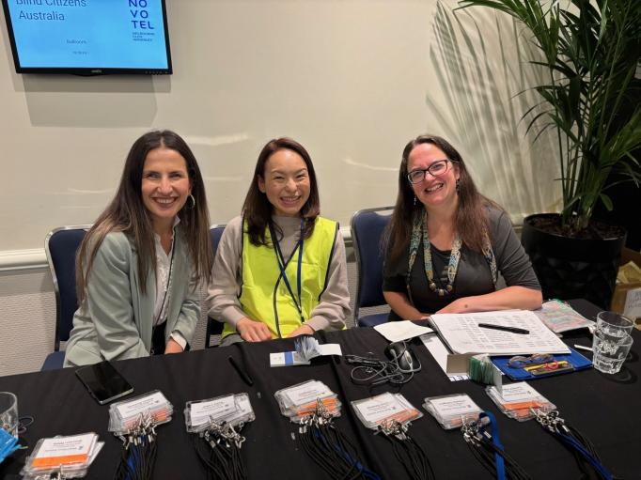
Thank you to our sponsors Vision Australia, Guide Dogs NSW/ACT, Guide Dogs Victoria, Quantum RLV, Haigh’s Chocolates, Treasury Wine Estates, Victoria Hotel, Blue Diamond Transfers, L’Occitane en Provence, Braille House, BindiMaps and Buck McFarlane from Cocky Guides. We also thank Canon for collaborating with us on a tactile 3D print project.
Image description: Dozens of attendees sitting at their tables during a BCA Convention session. Some have their mobile phones out and are taking photos.
Image description: Martin Stewart, BCA National Advocacy Officer, and David Blyth sat next to each other. They are smiling in the photo.
Image description: Deb Deshayes, BCA CEO, and David Blyth handing the 2025 David Blyth Award to recipient John Machin.
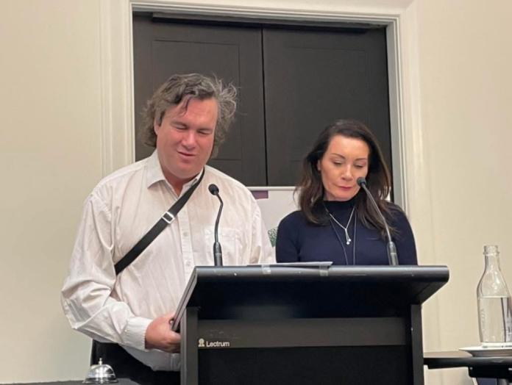
Image description: BCA staff members Layal Hage and Angela Jaeschke smiling in a photo with volunteer Hiroko.
Image description: Vaughn Bennison, BCA President, and Deb Deshayes, BCA CEO, standing together at the lectern.

Other Events
BCA continued to engage with members via BCA Conversations - an online event for our members to connect with their peers and discuss different topics. Some of the conversations this year have covered topics such as Reorganisation Q&A, considering the future of our radio segment New Horizons and the importance of orthoptics.

Peer Connect Groups
BCA’s Peer Connect groups are designed to enable members to catch up with others online to discuss a shared interest, hobby, or passion, and to share tips and tricks on particular topics.
This year, nine groups met at least monthly, each group hosted by a BCA member. Most groups also have an email list to promote discussion and information sharing between sessions. Topics this year included employment, travel guides, art appreciation, book club, assistive technology, gardening, guitar, music and acquired sight loss.
BCA continues to engage with younger members aged 18 to 34 years. A Discord channel continues to connect younger members, offering opportunities for social connection, gaming nights and updates from the sector. This has proven to be a popular way for BCA’s younger members to engage with each other.
BCA’s Trivia nights on Saturday evenings have continued to be a popular way of connecting online in a social setting, with an average of 20 to 25 participants each week. We thank all Trivia hosts, members, staff and board who made this possible

International Work
BCA engages internationally primarily through its memberships in the Pacific Disability Forum (PDF) and the World Blind Union (WBU), particularly in the Asia Pacific region (WBUAP), where Australia is located.
This year, BCA continued its involvement in global initiatives through participation in the WBU and maintained representation on several key international committees.
BCA holds a prominent role in the governance of the WBU Asia Pacific region. Ben Clare continues to serve as the Oceania Subregional Chair, while Robyn Mckenzie represents BCA at the International Council for Education of People with Visual Impairment (ICEVI) and as a member of the WBUAP Communications Committee. Helen Freris also serves as a regional board member.
The Asia Pacific region’s activities this year included the production of two issues of East Wind, the region’s newsletter, which was shared with BCA members and other stakeholders. The WBUAP Board and Policy Council have also been preparing for the World Blind Union General Assembly, a global event scheduled for September 2025 in Sao Paolo, Brazil.
BCA’s 50th anniversary celebration and Convention provided a wonderful opportunity to showcase BCA’s contributions to international advocacy. We were honoured to welcome Martine Abel-Williamson, President of the World Blind Union, who attended the entire convention and delivered a keynote presentation. In her speech, Martine paid tribute to former Australian presidents of the World Blind Union: David Blyth, for his advocacy against the use of blinding laser weapons, and Maryanne Diamond, for her pivotal role in negotiating the Marrakesh Treaty, which facilitates the cross-border exchange of accessible format materials. Martine also highlighted advocacy tools and resources produced by the World Blind Union over the past four years and encouraged attendees to visit the World Blind Union’s media and website for more information about its activities. Everyone is invited to learn more about the World Blind Union’s activities at https://wbu.ngo/
Also in attendance at BCA’s 50th anniversary Convention were participants from the Samoa Blind Persons Association in person, as well as members of United Blind Persons Fiji, who joined the proceedings online via Zoom. We extend our thanks to Ben Clare, World Blind Union Oceania Subregional Chair, and BCA staff members for facilitating the Zoom link and enabling the live participation of members from Fiji.
In July 2024, Helen Freris was elected to the Executive Committee of the Australian Disability and Development Consortium (ADDC) as BCA’s organisational representative. The ADDC is a network of disability, international development, and other interested organisations and individuals, focusing on advancing disability equity in Australia’s international development activities. The network advocates with the Australian Commonwealth Government for the prioritisation of disability equity in international development policies, funding, contract management and evaluation, and promotes best practices by sharing knowledge and resources across its membership and beyond. Through participation in the ADDC Executive Committee meetings and working groups, Helen and other disability sector representatives champion the importance and value of lived experience from disabled peoples’ organisations in countries where international development takes place.
As a voting member of the Pacific Disability Forum (PDF), BCA remains actively involved, contributing as resources allow.
Additionally, BCA participated in the Vision 2020 Global Committee, which focuses on promoting clinical low vision services and advocacy throughout our region.

Branches
BCA has nine branches around Australia, each serving the needs of members in particular regions or with special interests. Our branches are run by volunteer leaders and BCA supports them by connecting the coordinators together to share information, promote resource sharing and problem solving.
BCA’s branches hold in person and online events throughout the year, and we encourage our members to get involved with branches in their area to connect with their peers and to attend events. You can find out more about our branches and how you can get involved on the BCA website.
Our sincere thanks to branch leaders, committee members, volunteers and to all those who contribute to the work of our branches. In doing so, you provide our members with opportunities to connect with and learn from one another and to collectively advocate for changes which make a tangible difference in their local communities.

External Representation
BCA staff attend many external events to represent BCA, including speaking at conferences, as well as participating in panel discussions and workshops, and individual or one-off consultations. Below is a list of external events or consultations where BCA was represented by its staff:
AFDO – Disability Advocacy Conference
AFDO Education Policy Working Group
Audio Description:
- Research interviews
- Audio Description for Television Symposium: Legislation, Policy and AI
- Meeting with FreeTV Australia
- Audio Description Symposium - Curtin University
- Meeting with the Hon Michelle Rowland (Minister for Communications)
Disability employment service reform research interview
Consultation by the NSW Government Department of Communities and Justice (DCJ) on the development their Disability Inclusion Action Plan
‘Defining Communication’ Roundtable coordinated by Deakin University
Disability Aviation Standards Co-Design Workshops
DFFH Emergency Preparedness and Engagement Forum
NDIS Foundational Supports consultation, specifically focused on the needs of people who are blind or vision impaired
My Aged Care: Federal Department of Health and Aged Care on changes occurring under My Aged Care
National Assistive Technology Alliance Annual Roundtable
Meeting with Octagon, a global entertainment company working on developing haptic feedback clothing for the Australian Open
Public Hearing for NSW Joint Standing Committee of Electoral Matters
Regular AFDO Member Policy Forums
Round Table on Information Access for People with Print Disability Conference
South Pacific Educators in Vision Impairment (SPEVI) Conference
Tasmanian Attorney-General consultation in relation to reform of Tasmania’s Electoral Act.
Victoria public transport Accessible Reference Group International Day of People with Disabilities event
Victoria Department of Transport - new ticketing systems testing
Victoria’s Department of Transport’s Accessibility Action Plan 2025-2029. Victoria Police Accessibility Action Plan
Woolworths consultation to support the development of their Disability Access Plan
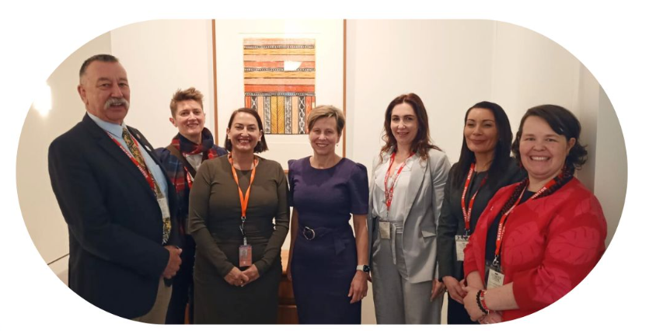
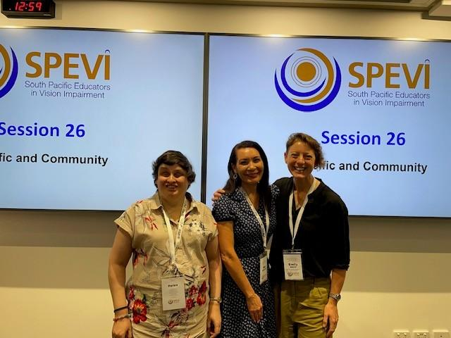
Image description: Helen Freris, BCA Vice-President, Deb Deshayes, BCA CEO and Emily White, ICEVI Pacific Regional President, standing in front of a large screen with the words “South Pacific Educators in Vision Impairment. Session 26. Pacific and Community,” behind them.
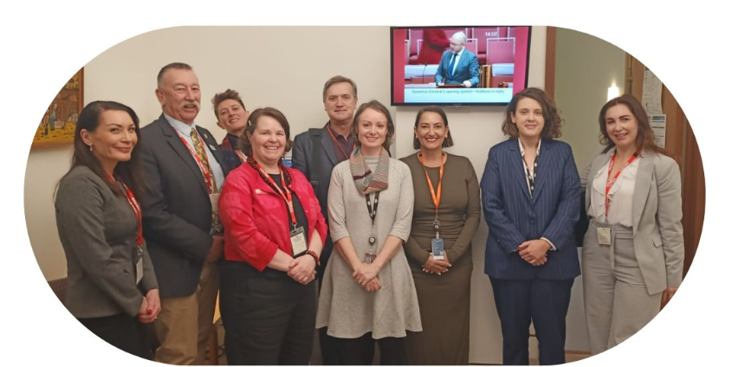
Image description: A group photo from the Australian Federation of Disability Organisations' (AFDO) Disability Advocacy Day in Canberra. Seven people, including Deb Deshayes, BCA CEO, are standing together, smiling in a meeting room at Parliament House, with framed artwork behind them. The group includes Minister Jenny McAllister.
A group photo from the Australian Federation of Disability Organisations' (AFDO) Disability Advocacy Day in Canberra. Nine people, including Deb Deshayes, BCA CEO, are standing together in a meeting room at Parliament House. Behind them is a TV screen showing a Senate broadcast.

Committees and working groups
BCA receives many invitations to participate on committees and working groups. These committees and working groups engage the disability sector in a conversation on accessibility in a range of government and business sectors and projects. These included:
- Standards Australia - Access for People with Disability
- Assistance Animal Advisory Committee - Taxi and Rideshare Services (AACTRS)
- Assistive Technologies For All (ATFA) Alliance
- Audio Description sector working group
- Australian Disability and Development Consortium
- Australian Banking Association
- Australian Electoral Commission Disability Advisory Committee
- Australian Federation Disability Organisations (AFDO) Members Forum
- Australian Federation of Disability Organisations (AFDO) Policy Network Forum
- Canberra Blind Society
- Communications Accessibility Consultative Committee
- Dept. Social Services DRO Forum
- Disability Advocacy Victoria
- Disability Discrimination Commissioner Roundtable
- Disability and Health Sector Consultation Committee (DHSCC)
- Disability Interagency Policy Group
- Disability Support Pension - Disability Peak Bodies with Services Australia and Department of Social Services (DSS)
- DSS - Australian Disability Strategy (ADS)
- DSS – Disability Representative Organisations working group (Accessible Communication)
- DSS Joint Quality Framework and Participant Experience Reference Groups
- Equal Access to Democracy (EAD) Disability Reference Group (NSW Electoral Commission)
- EverAbility
- Guide Dogs Australia
- Micromobility Discussions (Lime, Neuron, Beam, Ario, etc)
- National Disability Insurance Agency (NDIA) - Dog Guides Advisory Group
- NDIA Disability Representative and Carers Organisations (DRCO) Forum
- NDIS Quality and Safeguards
- NDIS/Vision 2020 Stakeholders Meeting
- NSW Accessible Transport Advisory Committee (ATAC)
- NSW Disability Advocacy Network (NDAN)
- NSW Disability Policy Interagency Meeting
- NSW/ACT NDIA Monthly Updates
- Pacific Disability Forum
- Parramatta Light Rail Project
- Round Table on Information Access for People with Print Disability
- Sensory Coalition Group
- Tasmanian Electoral Commission Working Group
- Telecommunications Ombudsman Consumer Panel
- Victorian Accessible Transport Advisory Committee (ATAC)
- Victoria Police Disability Portfolio Reference Group
- Victorian Education Committee - Disability Stakeholders Reference Group
- Victorian Electoral Access Advisory Group
- Vision 2020 Australia
- Vision 2020 Australia Independence and Participation Committee (IPC)
- Vision 2020 Global
- Vision Australia
- World Blind Union - Australian Delegate
- World Blind Union Asia Pacific Executive
- Yarra Trams Reference Committee

How We Empowered

Individual Advocacy
Individual advocacy involves supporting people to exercise their rights by providing assistance to voice their concerns, access information, resolve discrimination issues, or to identify support options available to them.
This year, BCA closed over 49 individual advocacy cases, as well as providing information and advice to approximately 12 people each month on how to self-advocate.
Our staff provided advocacy on many issues, including:
Access to education
Access to technology
Access to housing
Access to legal systems
Access to Centrelink
Access to public housing
NDIS accessibility, access, plans and reviews
Navigation aid (e.g. White cane) denials
Dog guide access
Pedestrian safety, including Tactile Ground Surface Indicator (TGSIs)
Communication with real estate agents

National Policy Committee (NPC)
One of BCA’s great strengths as a Disability Representative Organisation (DRO) is the existence of the National Policy Committee (NPC), a constitutionally established standing committee of the BCA board, intended to drive the formation and review of the organisation’s public policy output.
The NPC provides a conduit by which the views of the BCA membership on matters of public policy can be articulated to the BCA board and acts as an important sounding board for BCA’s policy work.
BCA’s Policy and Advocacy Hub hosts BCA’s policy reports, position papers, submissions, resources and information. Updated position statements on Taxi & Rideshare services, Audio Description, and Accessible Procurement were developed by BCA’s Policy Officers, in collaboration with the NPC.
Thank you to Francois Jacobs, NPC chair until December 2024 and Vaughn Bennison who chaired from December 2024, for supporting this valuable work, which has been busier than ever over the past twelve months.
Thank you also to members of the NPC and the many members who provided feedback to our consultations and ensuring our policies reflect the needs and interests of Australians who are blind or vision impaired.

BCA’s Work in New South Wales
BCA is funded to support our NSW members through the Shirley Fund and the NSW Government’s Disability Advocacy Futures Program (DAFP).
Our work in NSW continues to be a strong area of focus, with a range of advocacy, consultation and collaborative initiatives undertaken across the state.
Following our contributions to the NSW Electoral Commission’s Technology Assisted Voting (TAV) Inquiry, we have continued to encourage the NSW Government to implement the recommendations outlined in the Final Report. This work has included multiple submissions and two invitations to appear before the NSW Parliamentary Joint Standing Committee on Electoral Matters throughout 2024.
In the area of transport, BCA welcomed the NSW Government’s announcement of increased penalties for drivers who refuse to accept assistance animals, raising fines up to $3,300. We continue to advocate for improved enforcement and education through our involvement in the NSW Taxi Council Disability Reference Group and other sector forums.
BCA also remains actively engaged in statewide emergency preparedness work. Our national advocacy in this space has informed our involvement in a NSW Government working group focused on improving safety for at-risk populations, including people with disability.
Accessibility in public transport continues to be a priority. In collaboration with Guide Dogs NSW and Vision Australia, BCA has worked with Transport for NSW on the introduction of AVAS (Acoustic Vehicle Alerting Systems) on the new electric bus fleet to ensure the sounds used are effective and safe for people who are blind or vision impaired. We have also continued to raise concerns about the installation of floating (island) bus stops in Sydney, participating in the Accessible Transport Advisory Committee (ATAC) and related consultations. BCA and our sector partners are advocating for greater recognition of the safety issues these designs pose and continue to share international research and lived experience in this space.
BCA has also been involved in accessibility discussions for large infrastructure projects including the North Metro Rail and Parramatta Light Rail. In 2025, we participated in an in-person site visit to Parramatta with Transport for NSW to inspect light rail services and raise safety and accessibility concerns directly.
We continue to work in partnership with Guide Dogs NSW and Vision Australia through regular meetings, collaborative submissions and shared representation across various government and sector-led initiatives.
BCA also supports five branches in NSW, in addition to the NSW/ACT State Division, and appreciates the ongoing efforts from members in supporting advocacy and peer connection events.

Individual Advocacy in NSW
BCA provides individual advocacy support to people who are blind or vision impaired across a range of issues. During 2024-25, BCA supported 17 individuals in NSW with matters including family court mediation, access to transport, Vision Australia training, taxi subsidy issues, medical care support, Centrelink, access to justice, dog guide refusals, access to information and technology, council legislation, app accessibility and access to banking.

BCA Hugh Jeffrey Scholarship
The BCA Hugh Jeffrey Scholarship Program offers up to $15,000 in total to support students who are blind or vision impaired in overcoming barriers to tertiary education. The scholarship aims to address the accessibility challenges faced by students, particularly in online learning environments, by providing financial assistance for adaptive technologies and support services, ensuring equitable access to education.
BCA was pleased to offer its fifth round of the BCA Hugh Jeffrey Scholarship to BCA members to support the accessibility of their higher education studies.
Congratulations to the recipients of the 2025 BCA Hugh Jeffrey Scholarship: Ava Bouchier, McGregor Debeljak, Erin Goedhart, Mark Warrington and Thientuoc Autran.

Campaigns

Audio Description
BCA and our sector allies continue to stress the importance of establishing audio description (AD) on commercial free-to-air Australian television, with the sector having seen some success in expanding AD services via public broadcasters ABC and SBS.
We continue to have a dialogue with the Public Broadcasters (ABC and SBS), Free to Air Australia, and the Federal Minister for Communications, to raise awareness and advocate for sustained funding and broader implementation of audio description across all free-to-air networks.
During this reporting period, BCA and Vision 2020 Australia met with Free TV Australia to continue discussions on expanding audio description services.
BCA also participated in a meeting with senior advisers in the Office of Communications, alongside other sector allies, to discuss the campaign to extend audio description to all free-to-air networks. The meeting also explored the development of an Associated Plan for Accessibility of Information and Communication.
We remain committed to working with the new Minister for Communications, Anika Wells MP, to keep progress moving.

Elections and voting

Federal Election
BCA has continued to advocate for the rights of people who are blind or vision impaired to participate in elections by casting a secret, independent, and verifiable vote.
During this reporting period, advocacy work included participation in the Australian Electoral Commission's (AEC) Disability Advisory Committee (DAC) to discuss preparations for upcoming elections and planned electoral reforms. In addition, we attended the meeting of the AEC Accessibility Working Group, which developed recommendations to inform the broader DAC.
BCA also hosted an Inform session in the lead up to the 2025 Australian Federal Election, which touched on important topics such as Audio Description, healthcare, aged care services, emergency preparedness, the regulation of e-scooters, the NDIS and the Disability Discrimination Act (DDA).

State Elections
Following a successful campaign by BCA and the Tasmanian Branch, BCA participated in a briefing by the Tasmanian Electoral Commission on legislative changes that enabled telephone voting in Tasmanian elections. BCA also provided feedback on how telephone voting could be effectively implemented to ensure accessibility and integrity.

Taxi and rideshare refusal
BCA continues to represent the interests of people who are blind or vision impaired on both the Victorian and NSW Accessible Transport Advisory Committees. Through regular meetings, we contribute to discussions focused on improving accessibility and inclusivity within the taxi and rideshare sectors.

Submissions
The following is a summary of submissions made by BCA during the reporting period:
Transport & Arts Committee (NSW Parliament) – Inquiry into e-Scooters and other micromobility
Joint Standing Committee on Electoral Matters (NSW Parliament) – Inquiry into increasing electoral participation
Joint Standing Committee on Electoral Matters (Tasmanian Parliament) Inquiry into the conduct of the 2024 Parliamentary Elections
Draft Aviation Customer Rights Charter
NDIA Independent Review of Art & Music Therapy
National Principles for the regulation of Assistance Animals
Review of the Federal Government Print Disability Services Program
Submission to Department of Social Services (DSS) Consultation into Foundational Supports
Submission to DSS on use of visual descriptions
BCA also endorsed submissions or open letters from the disability advocacy sector.

BCA Projects

An Eye to the Future
BCA’s An Eye to the Future Project has continued to strengthen opportunities for employment for people who are blind or vision impaired through a range of initiatives aimed at supporting job seekers, engaging employers, and increasing awareness of inclusive workplace practices.

Supporting Jobseekers
Throughout 2024-25, BCA supported job seekers through personalised assistance, group sessions and peer-led initiatives. Planning commenced for a new employment-focused Peer Connect group, with the group launching in May 2025 and still ongoing. Hosted by Jess Kendall, this group meets monthly and offers a space for peer support, shared experiences and employment-related discussion.
In May, BCA hosted a BCA Inform session focused on employment. The panel featured Kaye Jones from Guide Dogs Victoria Employment Services, Tim Haggis from disability support service Sky’s The Limit and Jess Kendall, who all shared their personal employment stories and offered valuable insights on navigating employment pathways as a person with disability.
As part of the BCA Convention in June, a dedicated employment session was facilitated by Rachael Johinke, Eye to the Future Project Coordinator, featuring panellists Dr. Graeme Innes, Rajdeep Reddy, and Siobhan Tierney (Director, IncludeAbility – Australian Human Rights Commission). The interactive session was hosted in person and live streamed, offering perspectives on inclusive employment from both lived experience and systemic advocacy lenses.
Additionally, a 1-hour workshop was delivered at Guide Dogs SA/NT, titled Self-Employment: Turning Passion into Purpose, empowering attendees to consider entrepreneurship as a viable employment path.
An e-Guide for job seekers and employers was completed, published on the Eye to the Future website, and distributed to attendees of webinars and sessions. Recordings of all workshops and webinars were also uploaded to ensure ongoing access to the materials.

Engaging Employers
BCA engaged in several employer-facing events during 2025 to promote inclusive hiring practices and increase the visibility of An Eye to the Future resources.
These included:
- An interactive presentation at the WorkAbility Expo in Adelaide (April 2025) titled Eye to the Future: Building Inclusive Workplaces That Work for Everyone.
- A 45-minute webinar in June for employers, HR professionals, disability employment services, and government bodies, covering respectful interactions, accessible recruitment, onboarding, training, and assistive technology.
- Representation and distribution of promotional materials at key events such as the Disability Employment Australia Conference and the South Australian Council on Intellectual Disability (SACID) Leading Through Inclusion event, with opportunities to connect with attendees and share information about the project.

Sector and collaboration and promotion
BCA has continued to develop and strengthen partnerships to expand the reach of An Eye to the Future. Throughout late 2024 and 2025, initial and follow-up meetings were held with a range of organisations including:
- Australian Human Resources Institute (AHRI)
- Australian Disability Network (ADN)
- Work180
- Vision Australia
- Guide Dogs Australia and state-based affiliates
These discussions have focused on cross-promotion of resources, collaborative events and tailored webinars for employer networks. Notably, Eye to the Future was promoted through Guide Dogs Victoria's Employment Services page and listed on the Australian Disability Clearinghouse on Education and Training (ADCET) website.
An Eye to the Future was also showcased at the Vision 2020 Australia Parliamentary Friends Group for Eye Health and Vision Care event in Canberra in late 2024 and further promoted through a LinkedIn campaign that commenced in 2025.
Staff also attended the South Pacific Educators in Vision Impairment (SPEVI) Conference in early 2025, enabling networking with educators and discussions around connecting students with vision impairment to accessible employment resources.
By the end of June 2025, Eye to the Future had been presented or represented at nine events, with strong sector interest and continuing opportunities for outreach and collaboration.
Below are the links to follow An Eye to the Future on social media:
An Eye to the Future Website
An Eye to the Future on Facebook
An Eye to the Future on YouTube

Feedback
BCA welcomes feedback on all its work, including advocacy, services, projects, events, publications and communications.

Closing Remarks
BCA has had another eventful and successful year, working to our vision and purpose of informing, connecting and empowering people who are blind or vision impaired and the wider community.
BCA’s achievements would not be possible without its members whose participation, attendance, input, and feedback guide our work.
Thank you for your support of BCA in 2024 to 2025. We look forward to your ongoing contributions towards another productive year ahead.

The BCA Team 2024 to 2025

Directors
Garry Adler (from December 2024)
Stephen Belbin, Vice-president (until December 2024)
Vaughn Bennison, President (from December 2024)
Lee Chong
Neale Huth
Helen Freris, Vice President
Francois Jacobs (until December 2024)
Robyn Mckenzie
Rajdeep Reddy (from December 2024)
Stefan Slucki (from December 2024)
Andrew Webster, Treasurer
Fiona Woods, President (until September 2024)

Finance, Audit and Risk Management Committee (FARM)
Andrew Webster, Chair
Mick Baker (until December 2024)
Lee Chong (until January 2025)
Rocco Cutri
Neale Huth (from February 2025)
Chris Hegios (from October 2024)
Deb Deshayes, BCA Chief Executive Officer
Angela Jaeschke, BCA General Manager - Operations
Erin Kingisepp, Accounting & Advisory Manager, NFPAS

National Policy Committee
Robert Altamore, ACT
Vaughn Bennison, Director, Chair (from December 2024)
David Gearin, NSW (from December 2024)
Ross Hurford, Queensland
Neale Huth, Queensland (until December 2024)
Francois Jacobs, Director, Chair (until December 2024)
John Krishnan, Tasmania (from December 2024)
Sirani McNeill, Victoria (from December 2024)
Matt O’Kane, NSW (from December 2024)
Rajdeep Reddy, Victoria, Director (from December 2024)
Debra Simons, Victoria
Stefan Slucki, Victoria, (Director from December 2024)
Nicola Stowe, New South Wales (until December 2024)
Parimala Srikanteshwara, Victoria (from December 2024)
Stephanie Sullivan, NSW
Mark Warrington, Tasmania (until December 2024)
Jackson Reynolds-Ryan, BCA Senior Policy Officer (until May 2025)

50th Anniversary Convention Committees

Program Committee
Garry Adler (co-chair) (from February 2025)
Annette Ferguson (co-Chair) (until January 2025)
Michael Janes (until March 2025)
Karen Knight (from March 2025)
Doug McGinn
Robyn McKenzie BCA director (co-Chair) (until February 2025)
Katrina Taylor

Celebrations Committee
Stephen Belbin BCA Director (co-Chair)
Amy Curran
Lynne Davis (co-Chair until September 2024, member thereafter)
Helen Freris (co-chair) (from December 2024)
John Hardie
Carmel Jolley
Susan Thompson

Logistics Committee
Amila Dedovic
Deb Deshayes
Angela Jaeschke
Samantha Marsh
Christina Micallef (until July 2024)
Sarah Reilly (from August 2024)
Sharon Mackenzie (April – June 2025)

50th Anniversary Convention Speakers
Emma Bennison
Natasha Brake
Jane Britt
David Blyth
Jonathan Craig
Michael Curran
Sheelagh Daniels-Mayes
Annette Ferguson
Helen Freris
Lauren Henley
Ryan Honschooten
Zel Iscel
Francois Jacobs
Bill Jolley
Stephen Jolley
Karen Knight
Lee Kumutat
Ramona Mandy
John Machin
Raj Reddy
Steve Richardson
John Simpson AM
Siobhan Tierney

CEO Oversight Committee
Helen Freris, Vice President
Neale Huth
Robyn Mckenzie
Fiona Woods (until September 2024)
The Board formally concluded the operations of the Committee in early 2025.

BCA Staff
Executive Leadership Team
Deb Deshayes, Chief Executive Officer
Angela Jaeschke, General Manager - Operations
Sarah Reilly, Executive Assistant
Fundraising
Craig Hunter, Fundraising Manager
Communications
Amila Dedovic, Communications Coordinator
Administration
Samantha Marsh, Information and Administration Officer
Finance Team
Not for Profit Accounting Specialists (contractor)
An Eye to the Future
Rachael Johinke, Project Coordinator, Eye to the Future
Policy and Advocacy Team
Policy Officer – Vacant at 30 June 2025
Martin Stewart, National Advocacy Officer
Layal Hage, Engagement and Consultation Officer
Former BCA Staff who served in the 2024 to 2025 financial year
Christina Micallef, Executive Assistant (until August 2024)
Theresa Ruig, Project Coordinator - Eye to the Future (October 2024 – January 2025)
Jackson Reynolds-Ryan, Senior Policy Officer (until May 2025)
Sharon Mackenzie, Contractor, Executive Assistant (August 2024), Admin Officer (April – June 2025)
BCA would also like to acknowledge and thank our volunteers for their work and commitment to the organisation.
End of document.

